

Test Report of customized firmware of DS-K1T331W for Latin America

|  |  |
| --- | --- |
| Report Name | Test Report of customized firmware of DS-K1T331W for Latin America |
| Test Performed By | Emilio Wang |
| Report Made by | Emilio Wang |
| Date | 2020-04-02 |
| Test Equipment used | DS-K1T331W (SN D72364655) |
| Test Firmware/Software used | V2.2.4 build200330 for DS-K1T331W  V3.2.0.10 build20191216 for iVMS 4200 |

**Test content**

#### Test model and version

Face recognition terminal:

DS-K1T331W

Firmware/Software:

V3.2.0.10 build20191216 for iVMS 4200

#### Test key steps. (Device customized version upgrade; verify QR code to open the door)

**1. Prepare**

1） Upgrade terminal to customized version, restore factory settings after upgrade

Note: After the upgrade progress on the device reaches 100%, it will not restart automatically. You need to manually power on again.

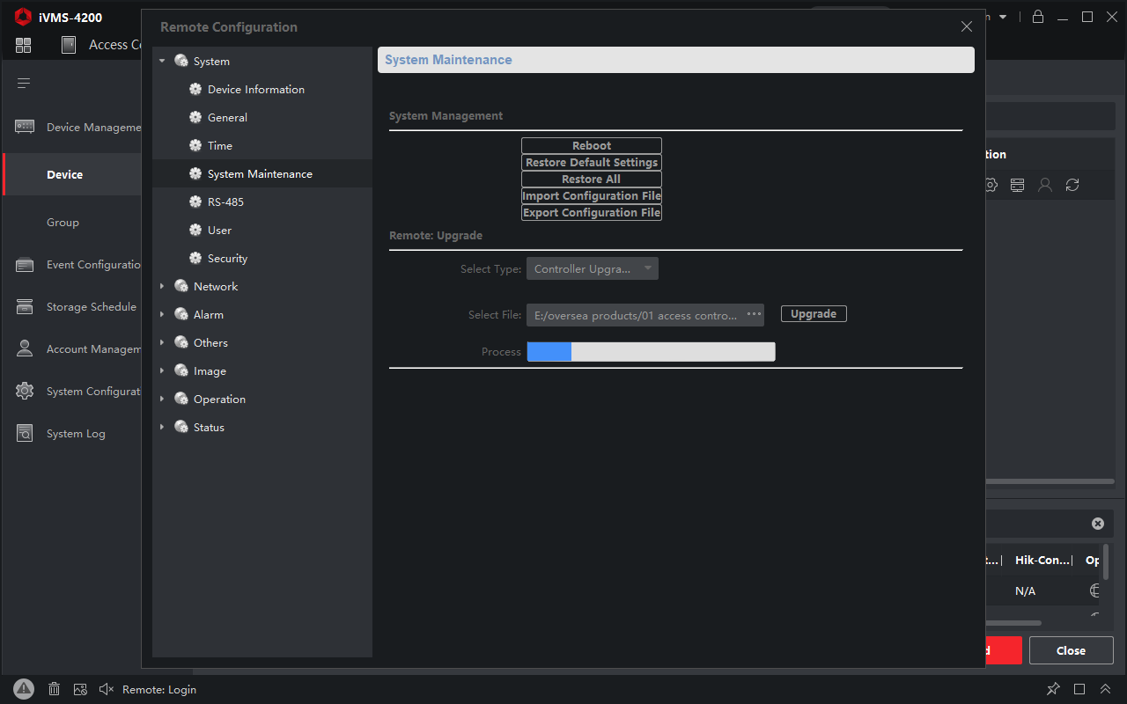

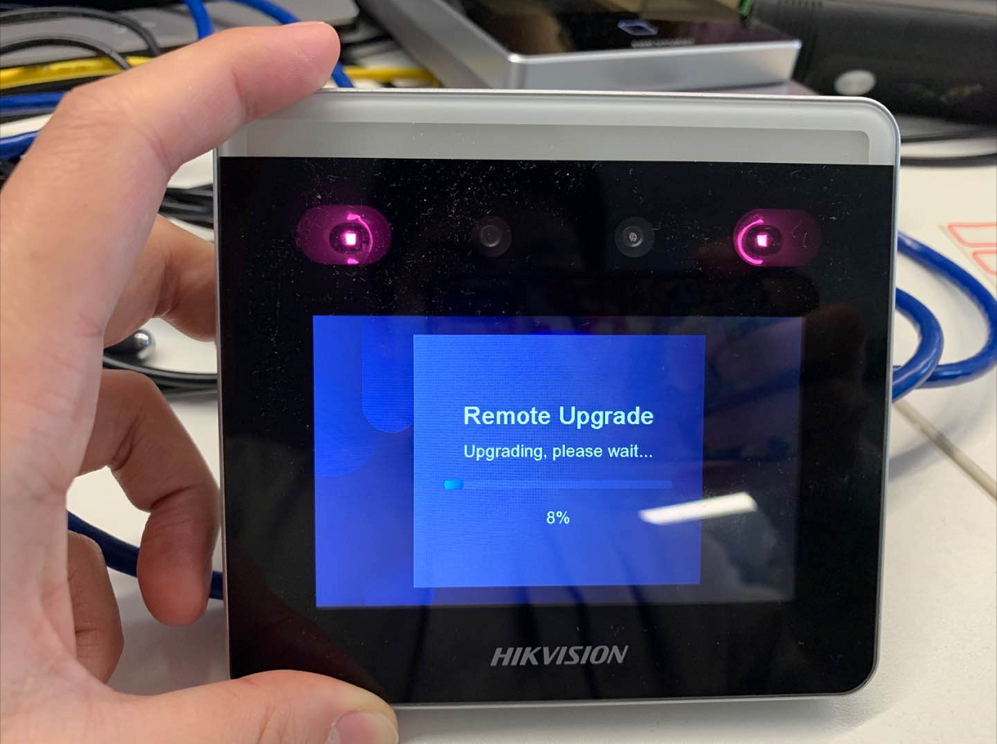

Equipment upgrade process

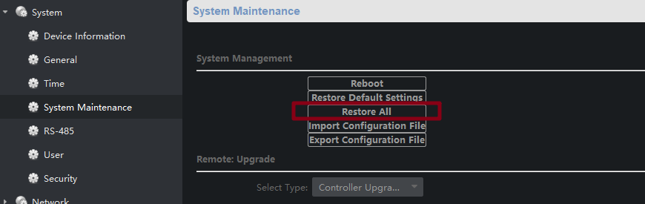

Restore factory settings after upgrade

**2. iVMS 4200 issue QR Code**

Enter the personnel configuration interface of iVMS 4200, select the person who needs to issue the QR code, and click Edit to enter the personnel information editing interface;

After filling in the personnel information, click the QR code icon in the upper right corner of the card to generate the person's QR code. Click the download button to download the QR code to the specified path.

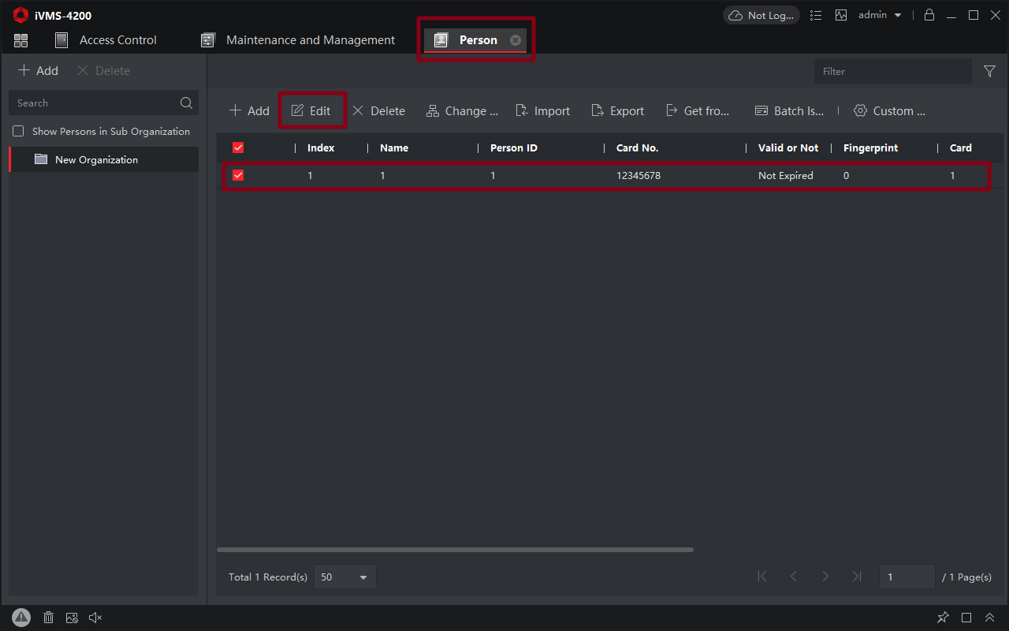

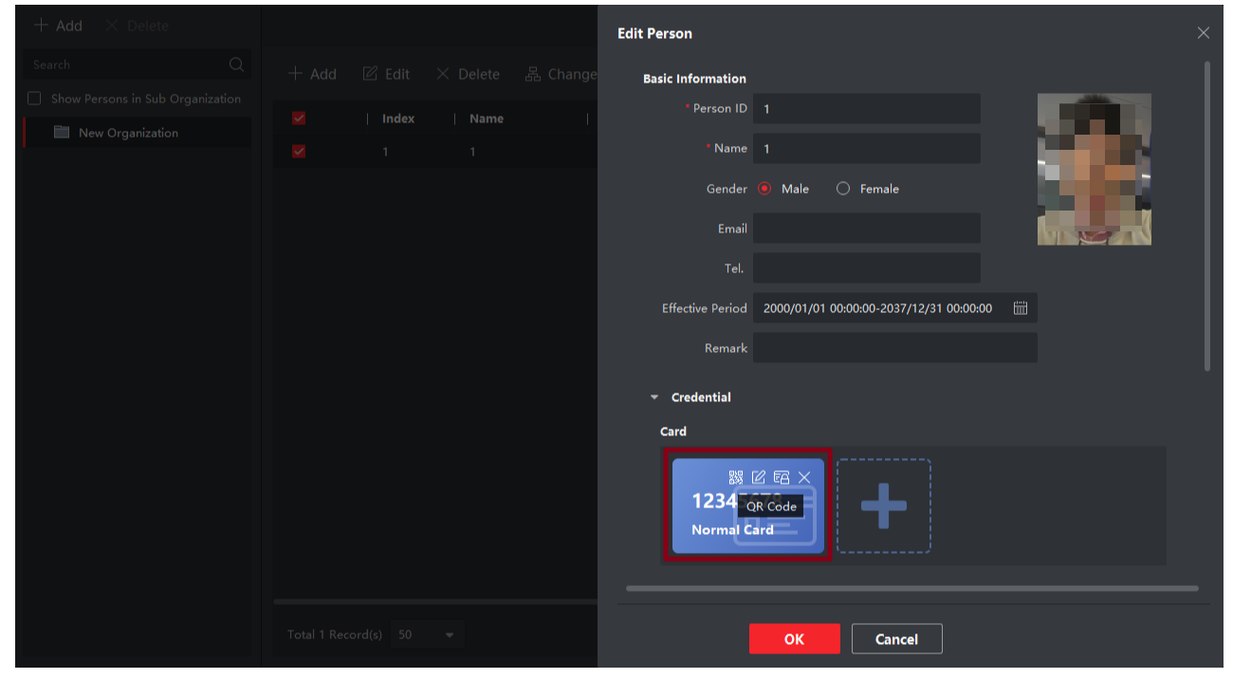

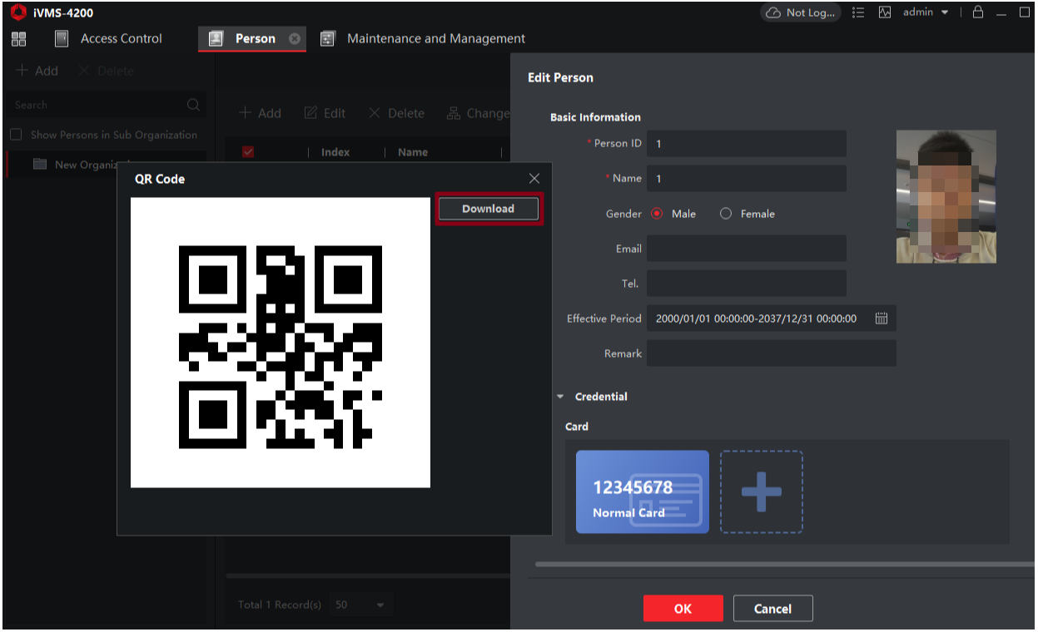

**3. Scan QR Code**

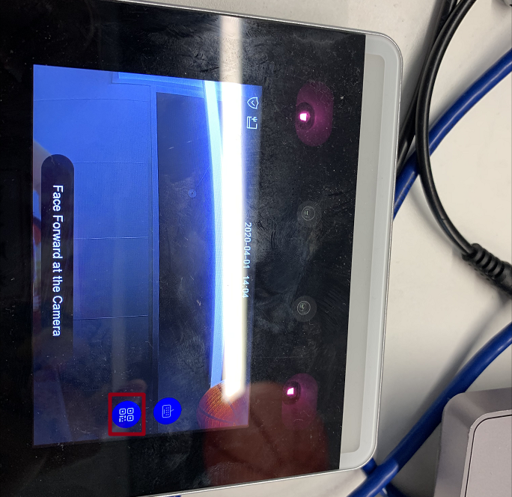

Click the QR code button on the right side of the device screen to enter the QR code scanning mode

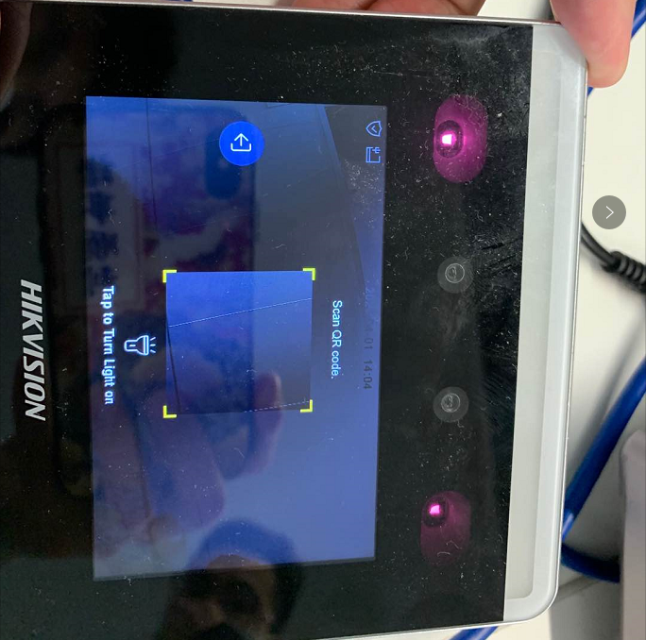

Scan mode, you can tap to turn light on

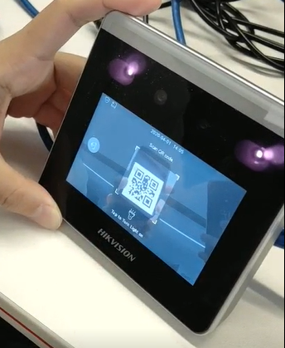

Scan the downloaded QR code

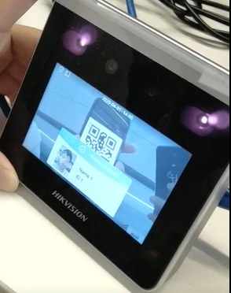

Verification success

#### DS-K1T331W Custom software functions and test conclusions

1. Support scan QR code to verification person information

Implement QR code identification interface, and display personnel information after verification