this firmware for DS-K1T500 working with intercom indoor stations, upgrade the device and then restore the device.

Pay attention to the instructions below:

1.       The firmware has to be working with indoor stations V1.4.23 (Baseline)

2.       After upgrading the devices, use the **baseline 4200 V2.6.2.7** to add DS-K1T500 and the indoor stations;

3.       Enter remote configuration of DS-K1T500:

**1.** Change the device name to **“100101”**

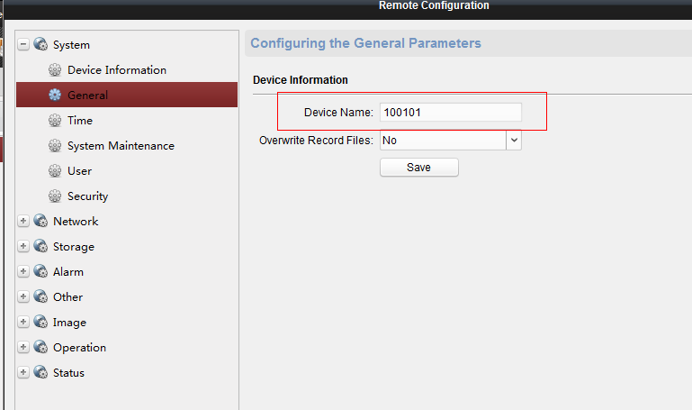

2.       Enter the local menu of the indoor station (if you use V1.4.23 baseline version, you can configure the room number in the software) and make sure the room number is 101 (it can only be 101),:

3.       Enter the “Linked network function” and configure the IP of the Door station, the door station type should be **D serie**;

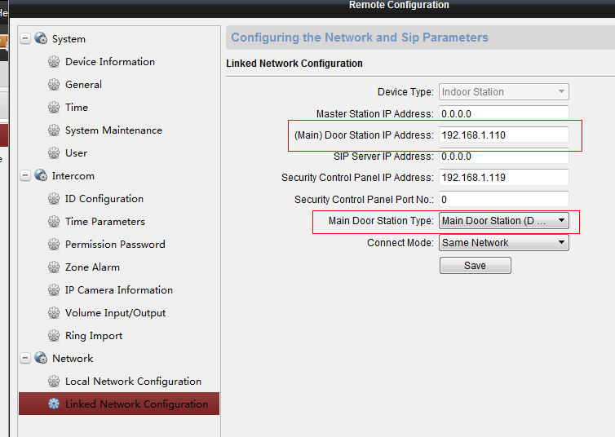

4.       If you need to call another indoor station in your house, it should be under mode “indoor extension” and from No 1 to No 5.

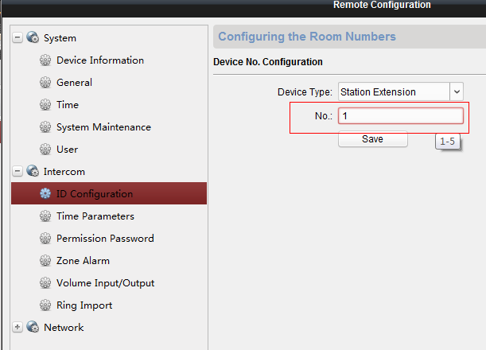

5.       Configure the main indoor station IP in the “linked network”

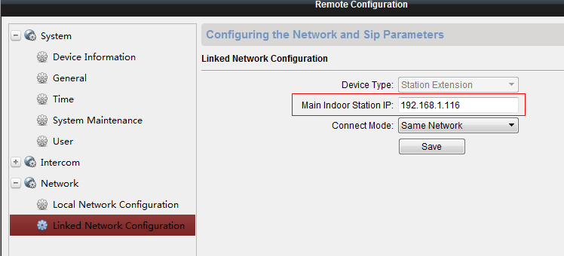

4.       Call the indoor station with the **left button** of DS-K1T500, call the iVMS-4200 using the **right button** of DS-K1T500.