K1T804 Series Access Control Terminal V1.1.1_build180619 Release Notes

|  |  |  |
| --- | --- | --- |
| **Device Model:**  DS-K1T804F  DS-K1T804EF  DS-K1T804MF  DS-K1T804F-1  DS-K1T804EF-1  DS-K1T804MF-1 | Firmware Version | **Access Control Terminal(For K1T804 series):**  ARM: ACS_1T_EN_GM_V1.1.1_build180619  MCU: ACS_Extending-Module_GM_1.1.1_180513 |
| SDK Version | HCNetSDK V5.3.5.40_build20180417_win32 |
| 4200 Version | V2.6.8.8 build20180424 |
| Ehome Version | EhomeSDK_V1.2.1.5_build20171101 |

Note:

1. please upgrade both MCU and ARM firmware together for fully upgrade.

Reason of Upgrade

Add or modify functions, fix bugs, enhance products quality and meet customers’requirements.

Modified Features

1. When device works in reader mode and under combined verification, fix issue about Wiegand34 output (if swipe card on device, it will output card number. when verify fingerprint, it will output card number which is linked to this finger, if input password, it will output the key value, only support upload duress code, dismiss code and super password).

**Note:** Device will output card number or key value only after all verify process finish (in combined verification mode, such as card+fingerprint)

1. 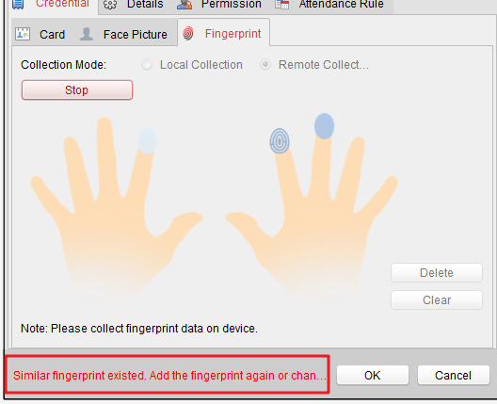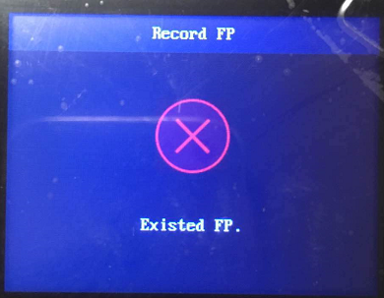Add Finger ID function (for checking duplicate finger when register fingerprint from device local or remote on software
2. Input method interface background color adjustment, optimize contrast, enhance the experience;
3. Optimize IP conflict checking function.

Customer Impact and Recommended Action

This new firmware upgrade is to improve product performance, and will take effect automatically after upgrading from previous versions. We’d like to inform you the above changes. Also, we are sorry for any possible inconvenience of use-habit changes caused by this action.

For questions or concerns, please contact our local technical support team.

Note:

* Hikvision has all rights to alter, modify and cancel this notice.
* Hikvision doesn’t give any guarantee for old models’ stock.
* Hikvision is not liable for any typing or printing errors.
* For special model’s change details, please contact our local technical support team.

Hikvision Digital Technology CO., Ltd.

No. 555 Qianmo Road, Binjiang District, Hangzhou 310052, China

Tel: +86-571-8807-5998

FAX: +86-571-8993-5635

Email: [support@hikvision.com](mailto:support@hikvision.com)