**K1T804 Series Terminal V1.1.2_build181117**

**Release Note (2018-12-03)**

|  |  |  |
| --- | --- | --- |
| **Device Model:**  DS-K1T804F/MF/EF  DS-K1T804F/MF/EF-1 | Firmware Version | ARM: ACS_1T_EN_GM_V1.1.2_build181117  MCU: Extending_Module_V1.1.2_build181116 |
| iVMS-4200 Client Version | V2.8.1.4 build20181124 |

**Note:** Both ARM and MCU firmware need to be upgraded.

**Reason of Upgrade**

Add or modify functions, fix bugs, enhance products quality and meet customers’ requirements.

**Modified Features**

1. Support setting RS-485 mode remotely (such as iVMS-4200 client software);

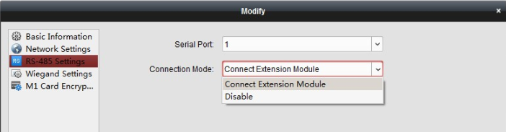

1. Support choosing Wiegand 26 or 34 for Wiegand output.(only DS-K1T804F/MF/EF model)

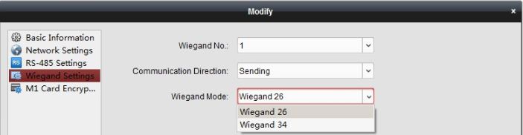

**Bug Fixed**

1. Fixed the permission applying bug on Hik-Central.

**Customer Impact and Recommended Action**

This new firmware upgrade is to improve product performance, and will take effect automatically after upgrading from previous versions. We’d like to inform you the above changes. Also, we are sorry for any possible inconvenience of use-habit changes caused by this action.

For questions or concerns, please contact our local technical support team.

Note:

* Hikvision has all rights to alter, modify and cancel this notice.
* Hikvision doesn’t give any guarantee for old models’ stock.
* Hikvision is not liable for any typing or printing errors.
* For special model’s change details, please contact our local technical support team.

Hikvision Digital Technology CO., Ltd.

No. 555 Qianmo Road, Binjiang District, Hangzhou 310052, China

Tel: +86-571-8807-5998

FAX: +86-571-8993-5635

Email: support@hikvision.com