

Test Report of customized firmware of DS-K1T501SF for Latin America

|  |  |
| --- | --- |
| Report Name | Test Report of customized firmware of DS-K1T501SF for Latin America |
| Test Performed By | Luna Li |
| Report Made by | Luna Li |
| Date | 2019-01-09 |
| Test Equipment used | DS-K1T501SF(SN213656392, 215599357)  DS-K1T501SF(SN213656392)  DS-KH8301-WT(SN771176943)  DS-KM8301(SN765560617)  DS-3E0109P-E(B)(SN864302579) |
| Test Firmware/Software used | V1.1.0build181224 for K1T501SF  V1.5.0build180622 for KH8301  iVMS4200 V2.8.1.4build20181124 |

**Test content**

1. **Hardware, software and system topology**

Terminal:

DS-K1T501SF (SN213656392, 215599357)

Indoor Station:

DS-KH8301-WT (SN771176943)

Master Station:

DS-KM8301 (SN765560617)

Switch:

DS-3E0109P-E(B)(SN864302579)

Firmware/Software:

V1.1.0build181224 for K1T501SF

V1.5.0build180622 for KH8301

iVMS4200 V2.8.1.4build20181124

1. **Key steps description. (When talking about video intercom functions of K1T501SF, it is called door station, otherwise it’s called terminal)**
2. **Preparation**
3. Upgrade the firmware of two K1T501SF to the customized version, then make sure that the firmware of KH8301 is V1.5.0.
4. After the upgrade, click **Reset All** (**Restaurar Todo**) in **Remote Configuration** (**Ajustes Remotos**) of K1T501SF.

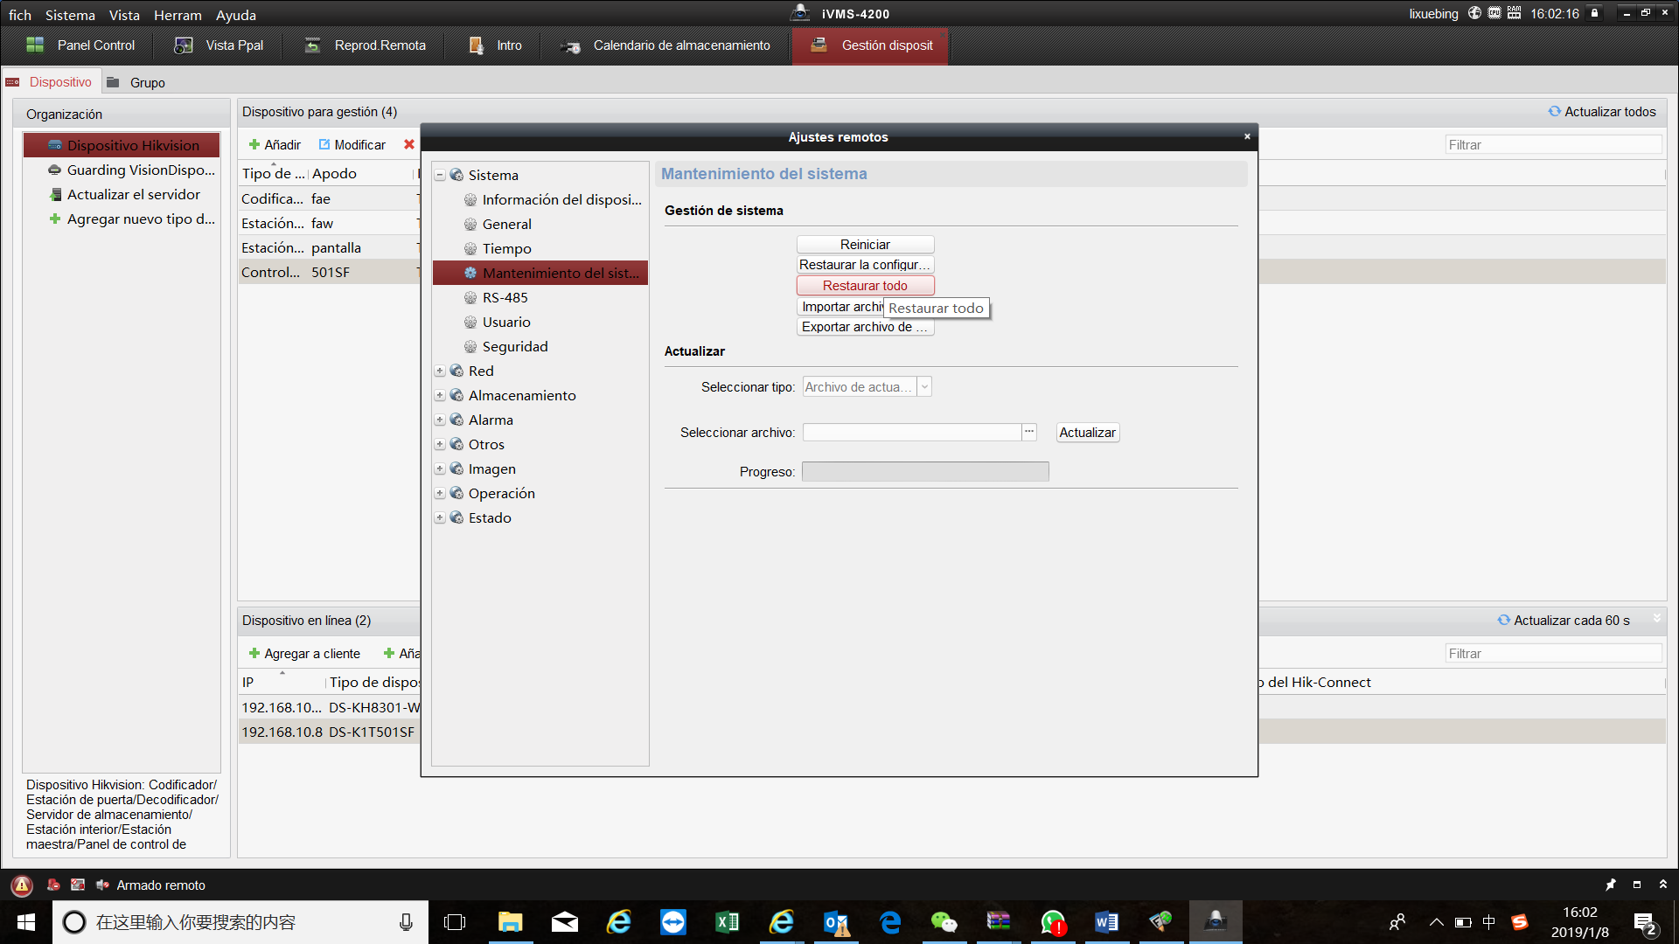

1. **Configuration in K1T501SF**
2. Change the device name to a number of 11 digits in **System**-**General**(**Sistema**-**General**), the format is *phase***building**department***floor*room number, all start with 1. In the names of main door station and sub-door station, the phase, department and floor must be the same. The numbers of floor and room coincide with the indoor station to be called.（example: the indoor station 101 corresponds to floor 001 room 01）

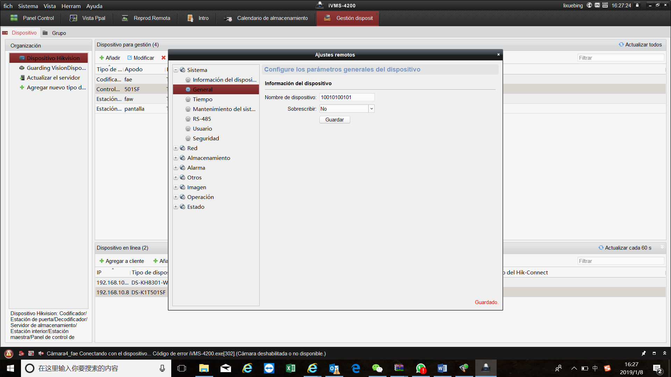

1. Configuration of IP and the number of the door station.

Go to **Internet-Advanced configuration** (**Red-Configuración Avanzada**) and input the IP direction of main door station in **IP of platform of security control** (**IP de plataforma de control de seguridad**) (It’s not necessary configuring it in main door station page)

Configure the numbers of doors stations in **Port of platform of security control** (**Puerto de plataforma de control de seguridad**). The number of main door station is 0, while the numbers of sub-door stations are from 1-99.

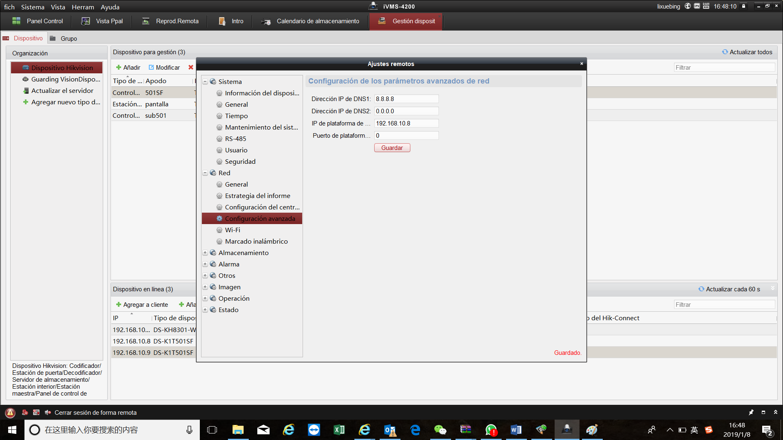

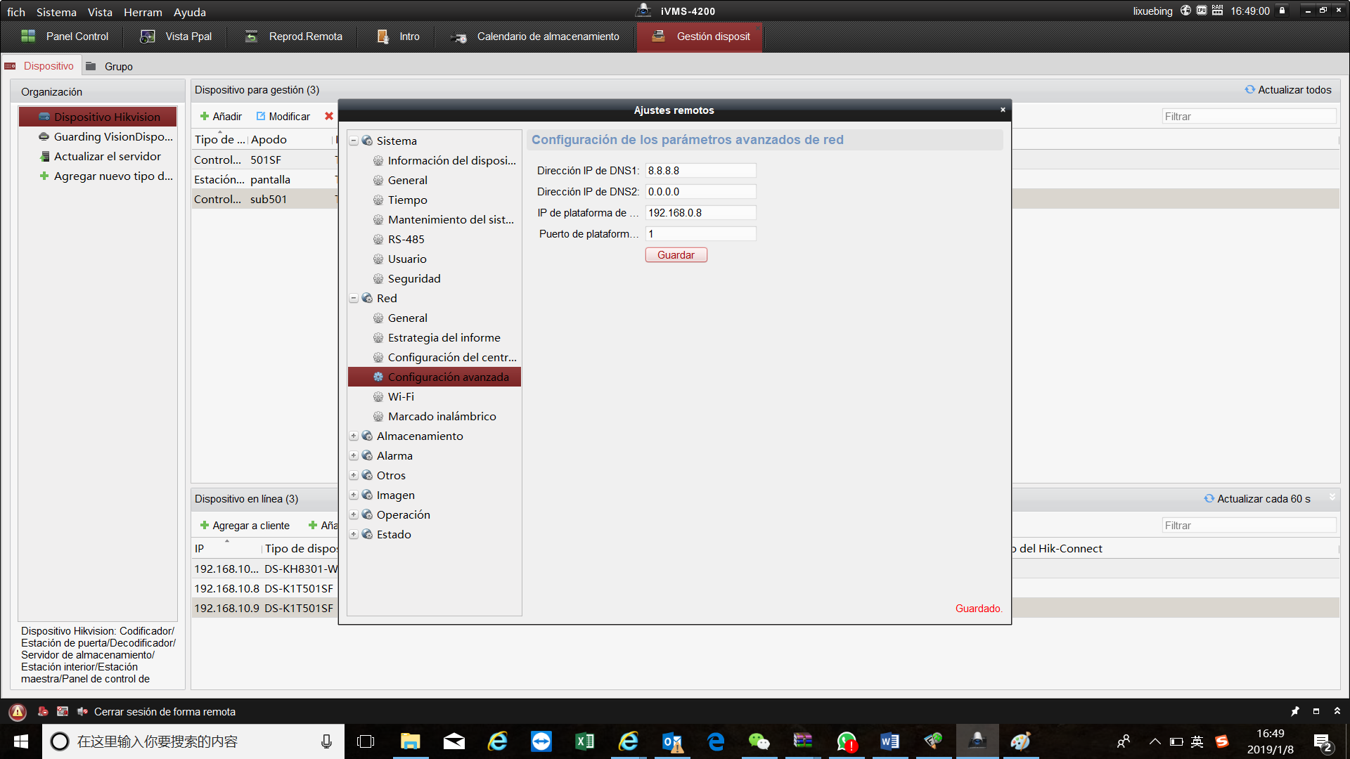

1. Go to **Access Control** module-**Advanced Function** (**Función Avanzada**) and choose the door. In **Activate block of the door when it´s closed** (**Activar bloqueo de la puerta cuando está cerrada**) choose **yes** (**Sí**). This step is to prevent automatic call to indoor station in failed authentication.

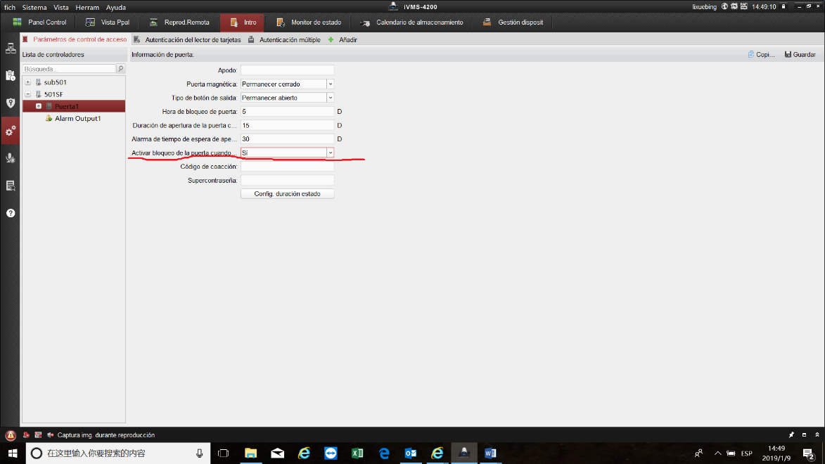

1. **Configuration of indoor station.**
2. Go to **Intercom-ID configuration** (**Intercomunicador-Configuración ID**) and input the room number that corresponds to the door station.

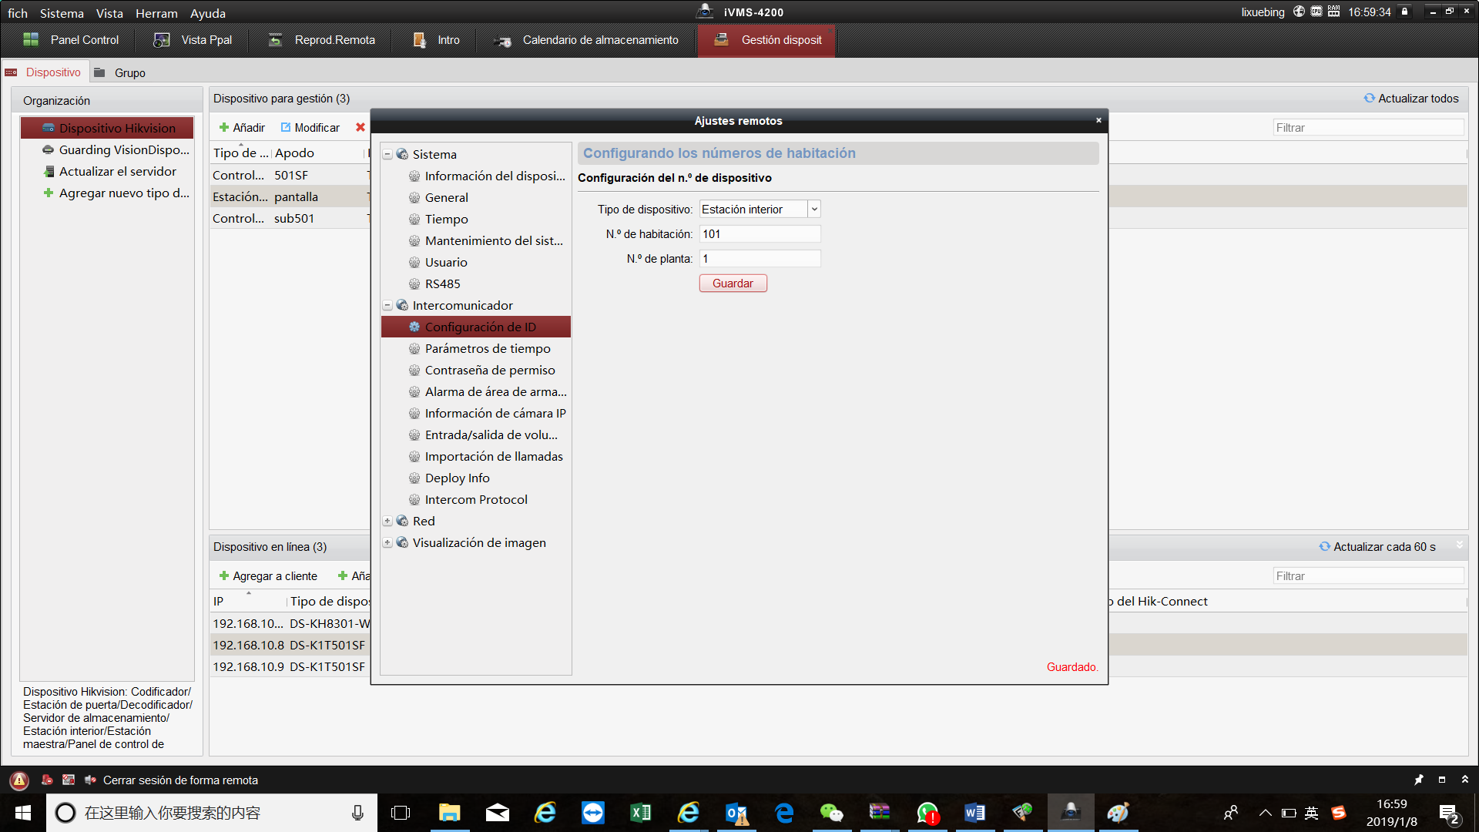

1. Go to **Network-Linked network configuration (Red-Configuración de red vinculada**) and input the IP of main door station.

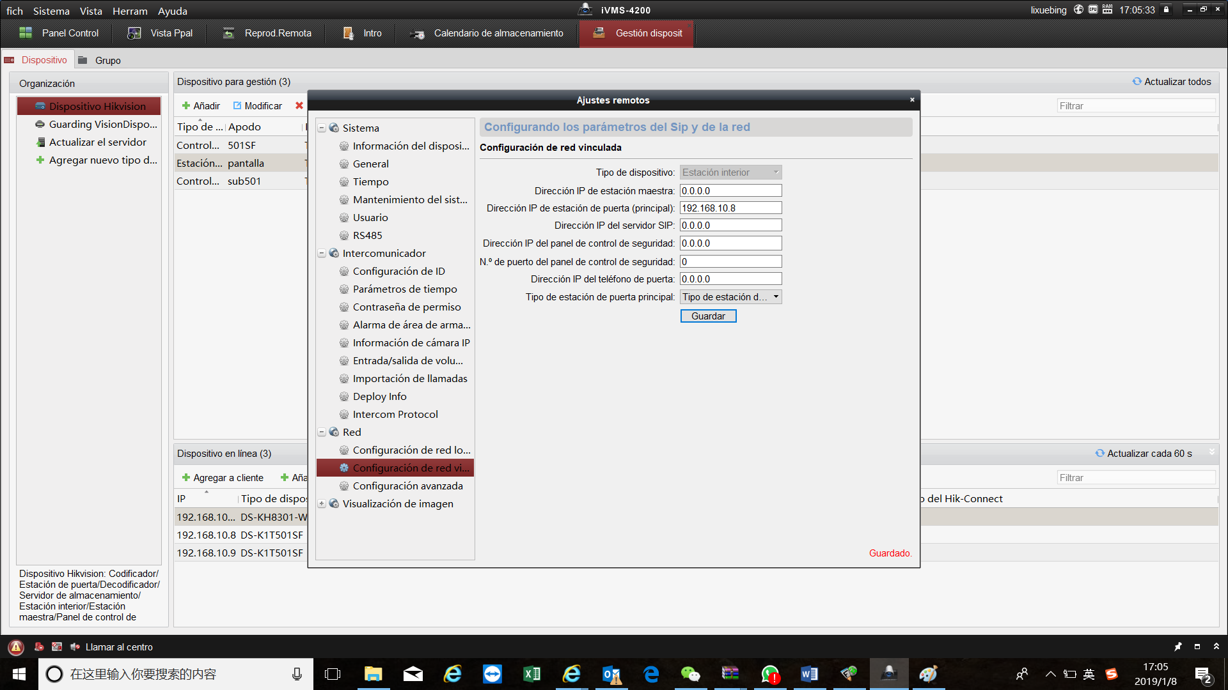

3.Go to **Intercom-Time Parameters** (**Intercomunicator-Parámetros de tiempo**) and set the **Max.Ring Duration**(**Duración Max. del Timbre**) as more than 30s.

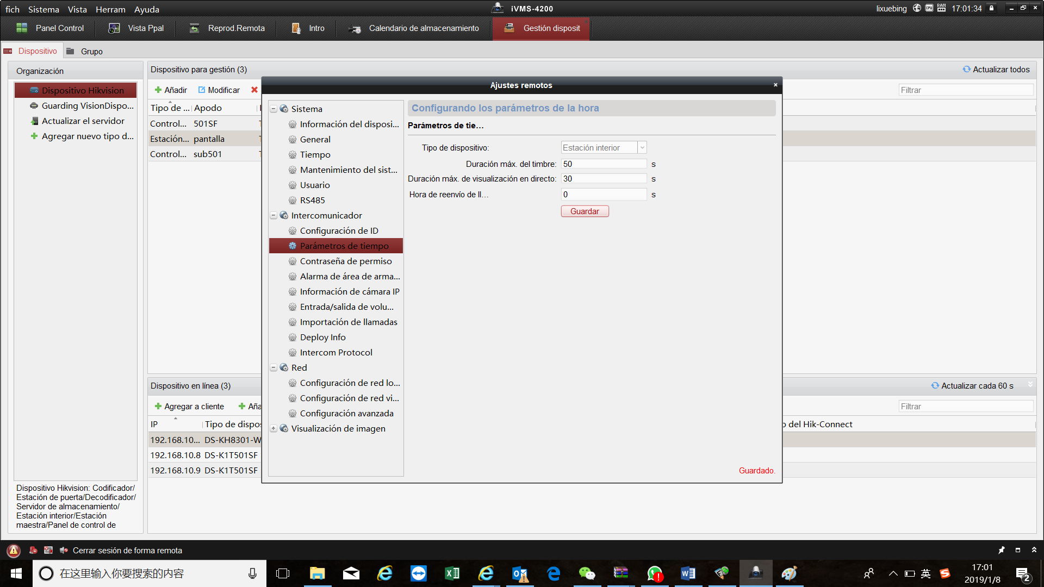

1. **Configuration of master station.**

Open sdkdemo, and configure the K1T501 like is shown the photo. The Groups must be **32** and input the IP of master station.

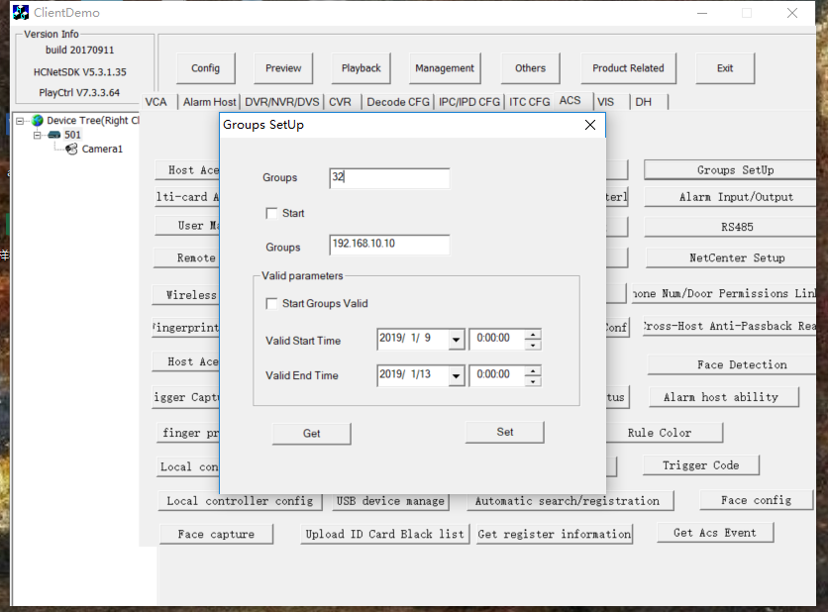

1. **Tests with the new functions.(Apply to both main door station and sub-door station)**
2. Press the telephone button of K1T501SF, and the indoor station can receive the call, see the live view, answer it(pressing **Contestar**), realize two-way audio and open the door(pressing **Desbloquear**). There are Spanish voices when the door is open (la puerta está abierta), when the indoor station refuses the call (La otra parte ha rechazado la llamada), when indoor station receives the call (por favor abre la puerta) or when the call ends (la otra parte ha terminado la llamada, llamada finalizada).

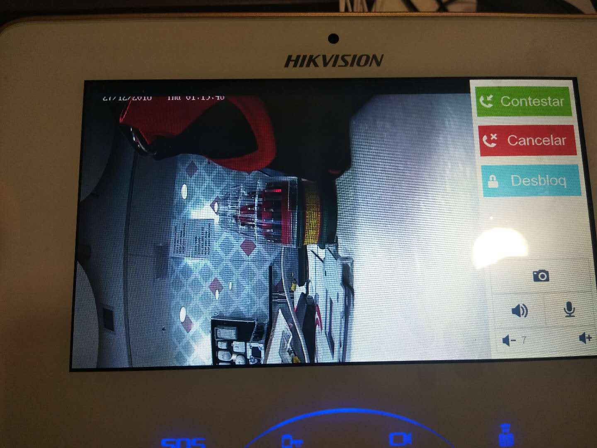

1. Before configuring the master station, press the doorbell button of both K1T501SF and after the voice of “Llamado al centro”, 4200 will receive the call and realize the functions exactly like the indoor station.

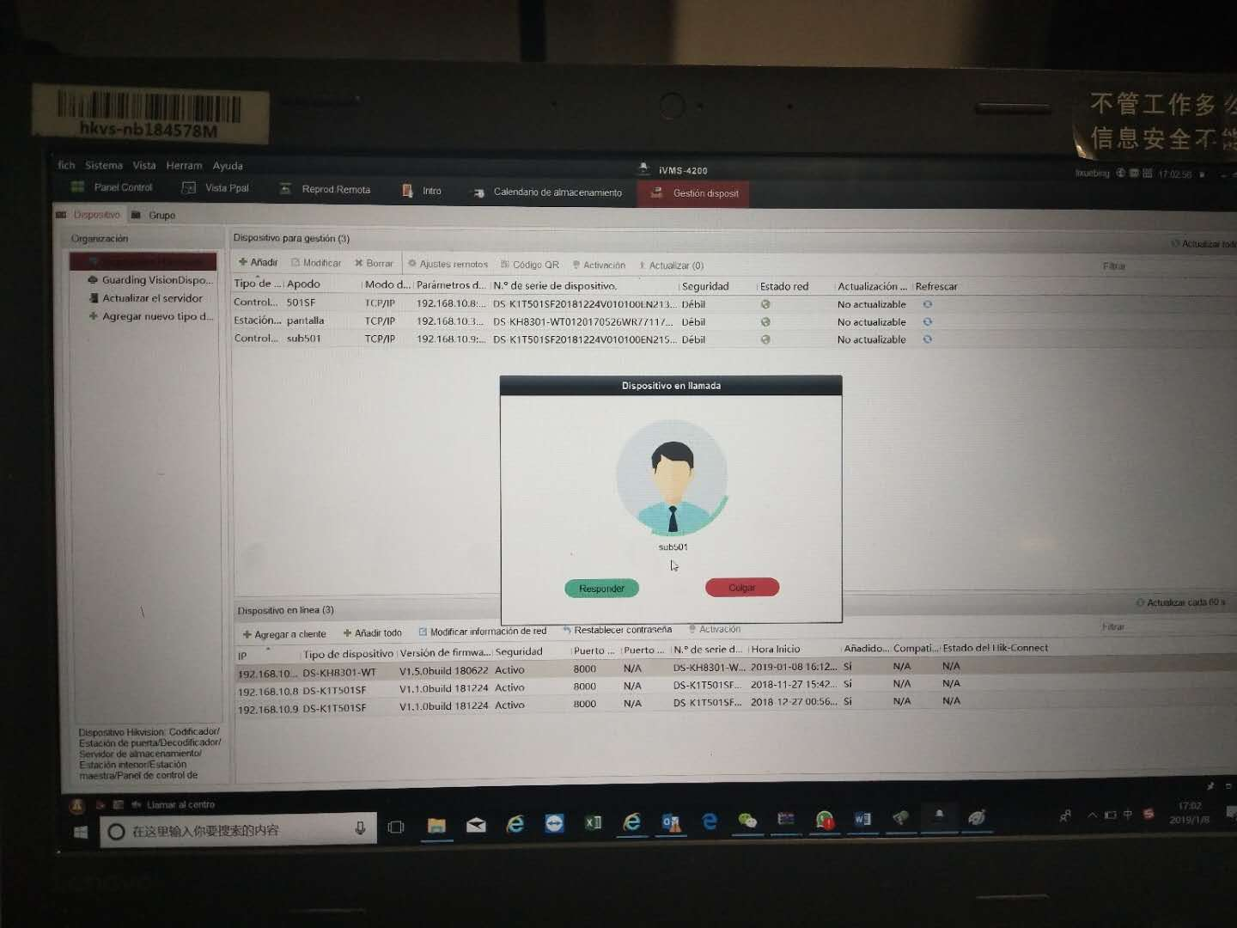

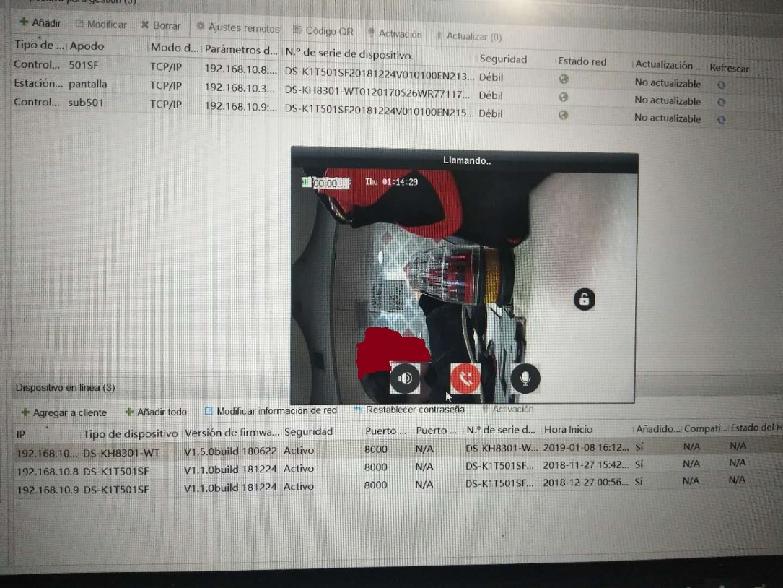

1. After configuring the master station, press the doorbell button and instead of 4200, the master station will receive the call and realize the functions like the indoor station.

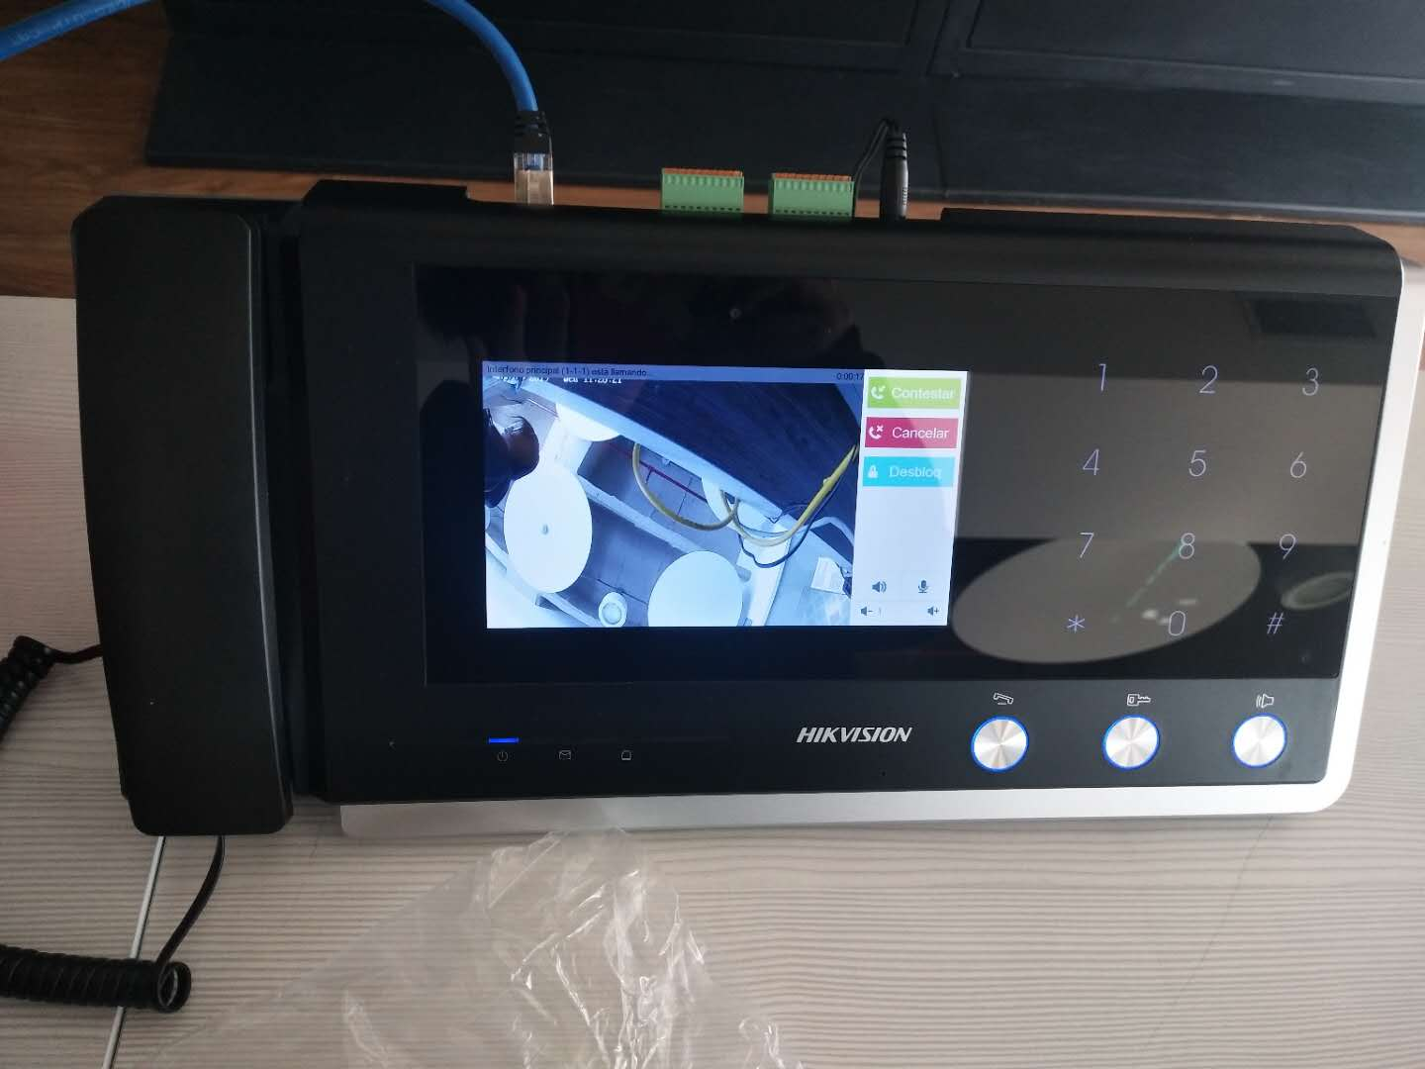

1. **Tests of conserved access control functions.**

Go to Access Control module of 4200, add person with card and fingerprint, then add template and apply permission. Then pass card or fingerprint in the terminal, there will be voices when authentication succeeds (verificación con éxito) or fails (verificación fallida). When authentication fails, no call will be made to the indoor station.

1. **Tests of functions related to Hik-connect.**

After connecting the door station to hik-connect, we can see the live view directly from the app and an icon showing the door status.

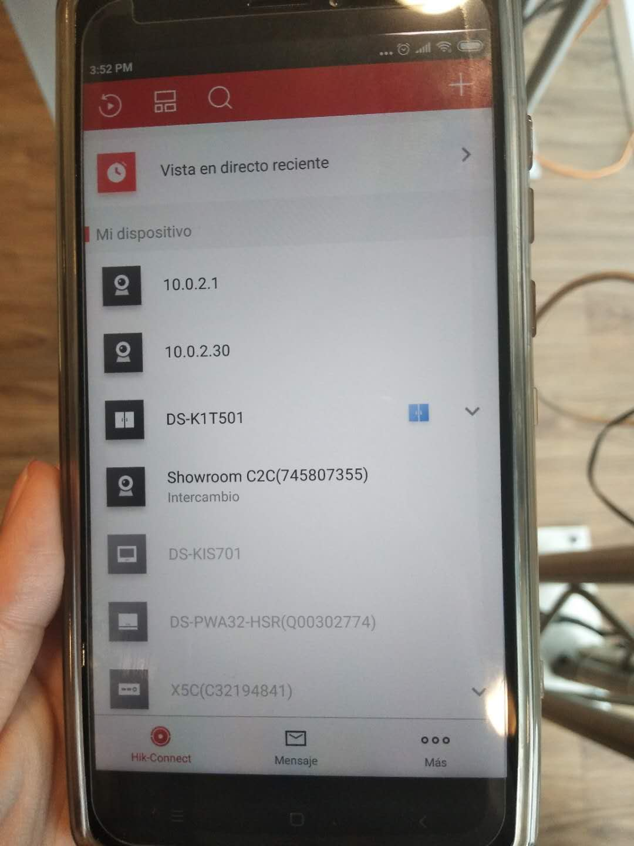

When pressing the telephone button of the door station, the app can receive the call, realize two-way audio and open the door remotely.

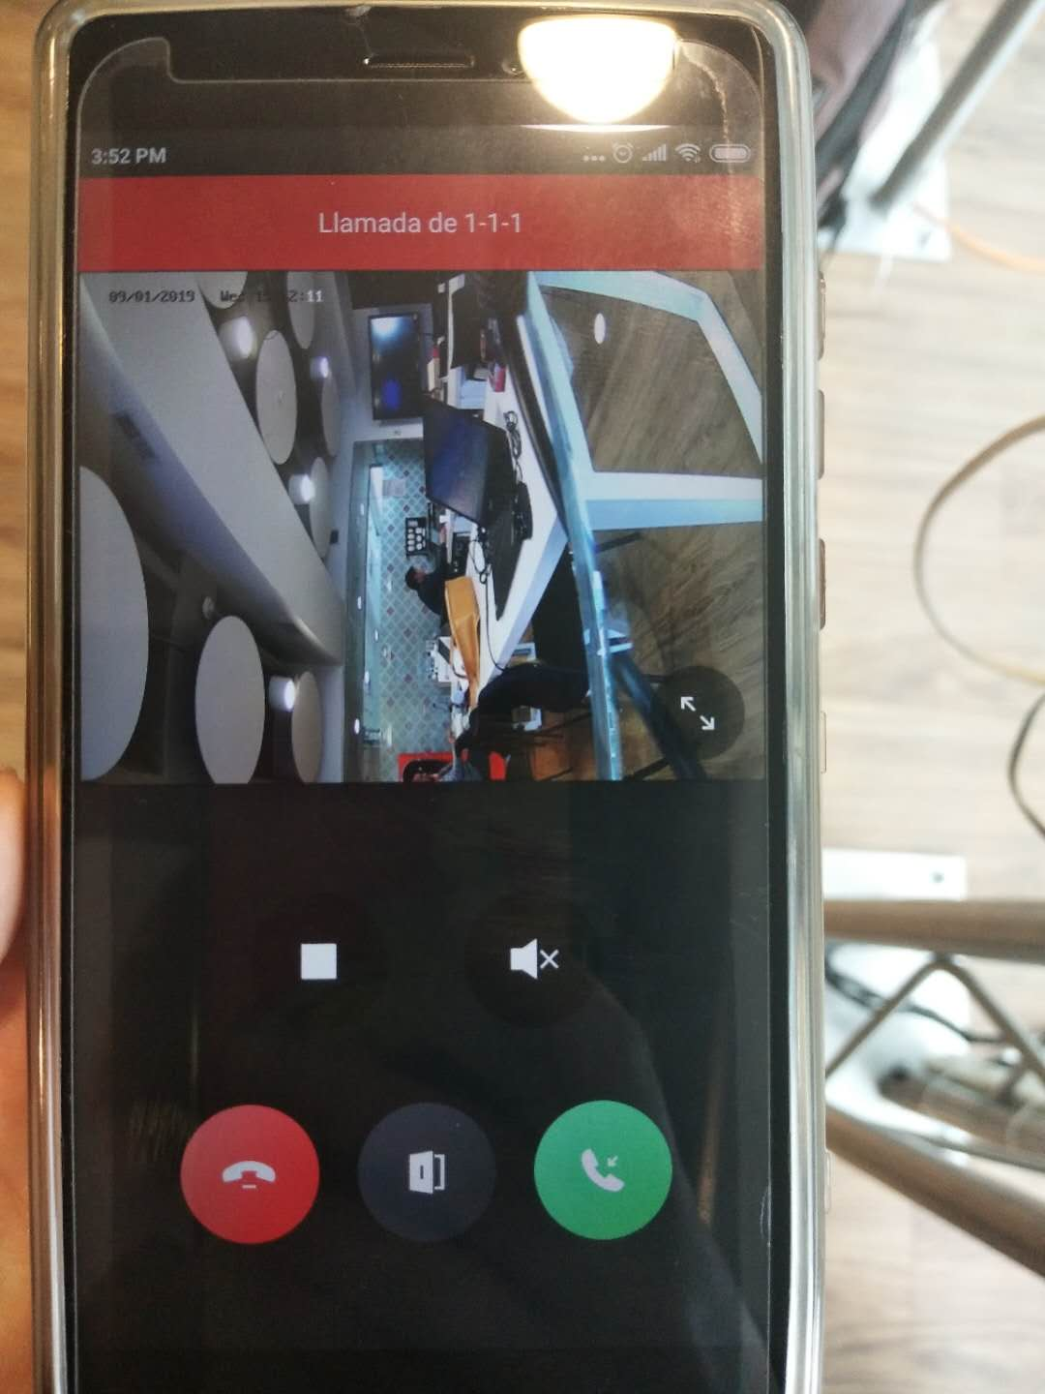

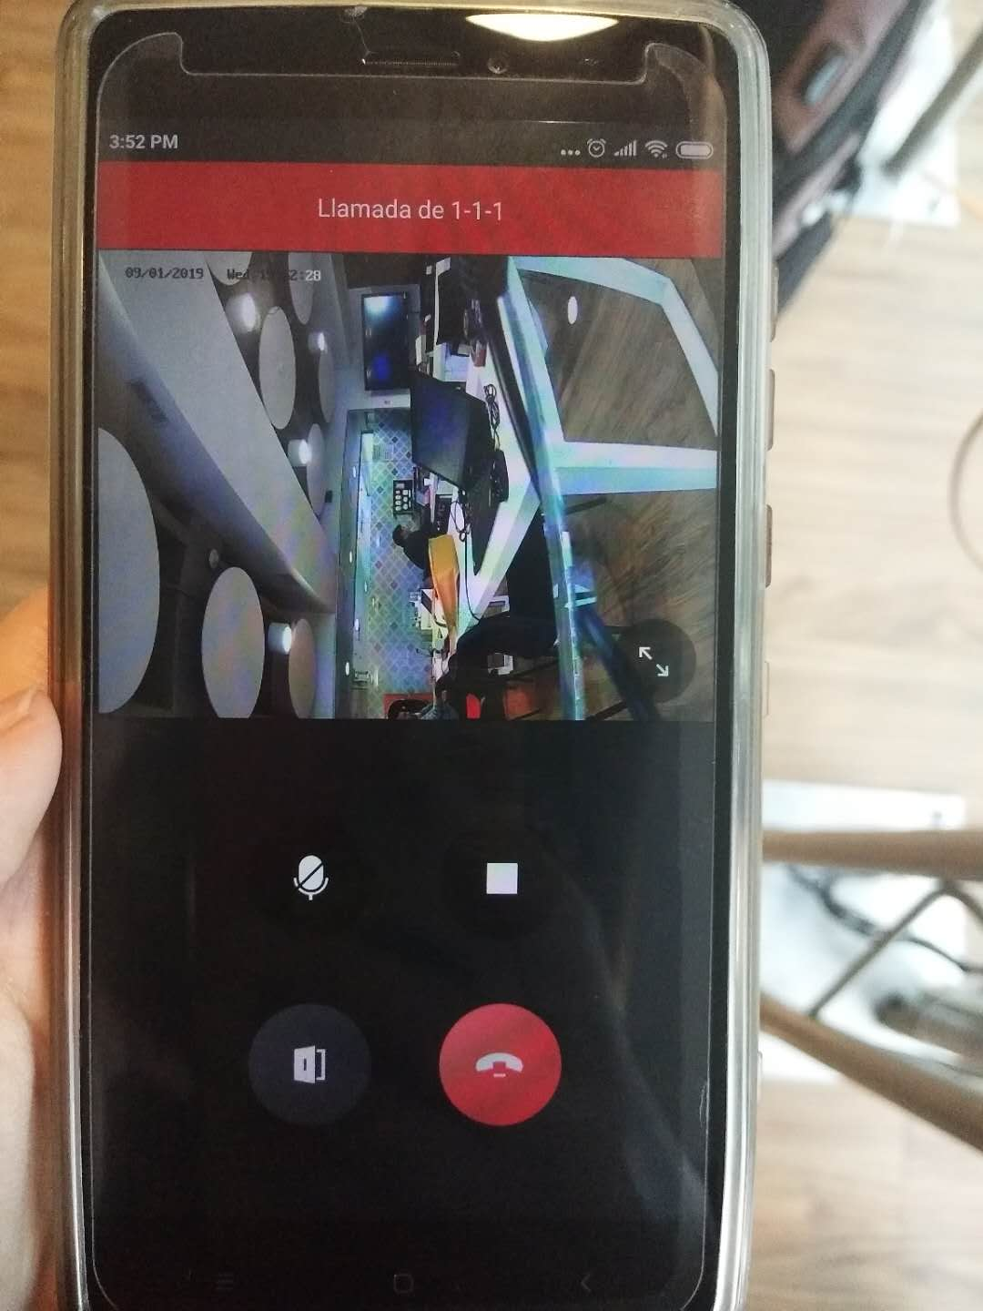

1. **Functions tested of the customized firmware of DS-K1T501SF.**
2. Supporting Spanish voice.
3. Being able to call indoor station of V1.5.0, realize two-way audio, remotely opening door from live view page of the indoor station as well as live view.
4. Calling the indoor station pressing the telephone button and calling 4200 pressing the doorbell button.
5. Being able to configure master station and calling master station by pressing doorbell button instead of 4200 after configuration.
6. Extension mode of K1T501SF.
7. Access control functions remained, including doorbell function, card or fingerprint authentication mode.
8. When authentication fails passing cards or fingerprint, K1T501SF won’t call the indoor station automatically.
9. Being able to call to Hik-connect, realize live view, two-way audio and remotely opening door.
10. **Conclusion**
11. The customized firmware of DS-K1T501SF supports Spanish voice.
12. The customized firmware of DS-K1T501SF provides the terminal with functions of door stations, such as calling indoor station, live view from indoor station, realizing two-way audio, opening door remotely and have sub-door stations.
13. The customized firmware of DS-K1T501SF allows the device to call to iVMS4200, master station and Hik-connect app, as well as realize functions like live view, two-way audio and remotely opening door.
14. The customized firmware of DS-K1T501SF conserves the original access control function of the device.
15. **Disadvantages**
16. As new functions are added to the terminal, we have to configure them in different pages and applications like SDkdemo, which makes it more difficult for the customers to handle.