**Quick Start Guide of DS-K1T502**

**Quick Start Guide of DS-K1T502**

1. **Activate the Device via Mobile Phone**

When the device is not activated, we can use the device AP hotspot connection to activate the DS-K1T502 device and connect to the device WEB for configuration operation.

1. AP Connection: the initial password is the device serial number, for example: K49645302.

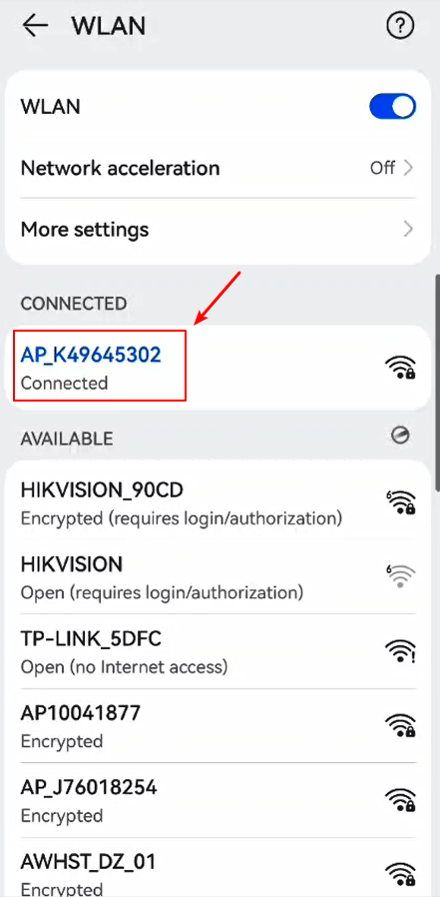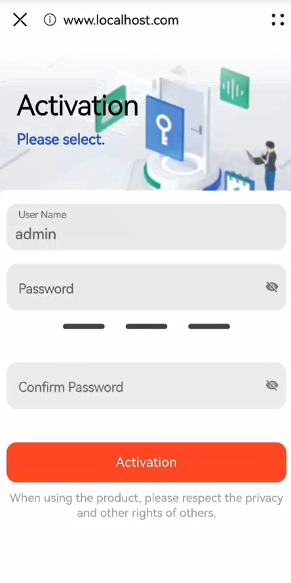

1. Activate the device: Activating the device requires setting a password, and subsequent connections need to use this password to connect to the hotspot.
2. Select three questions to answer and click Confirm. (If you forget the device activation password, you can change the password via security question.). Or you can choose E-mail method.

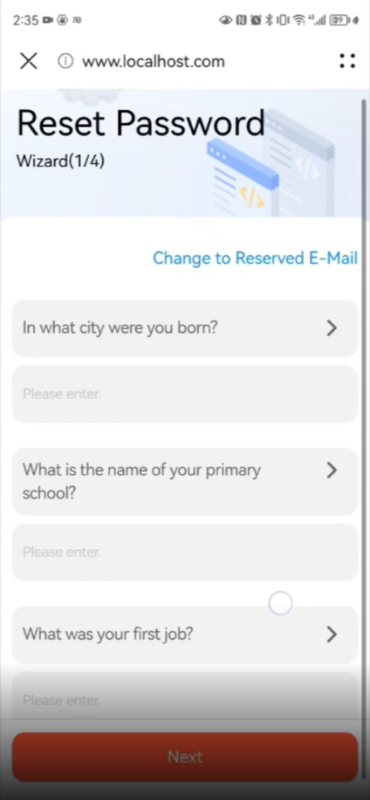 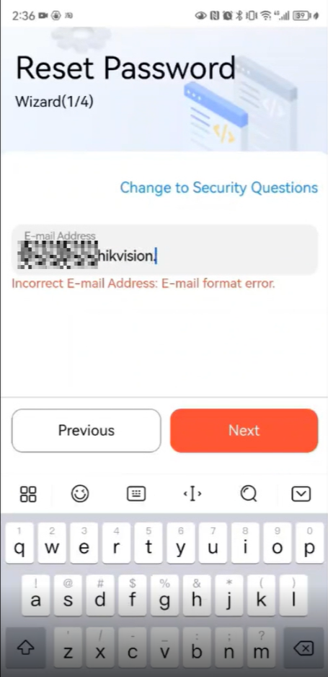

1. Choose device language. Communication Settings: Privacy Wizard:

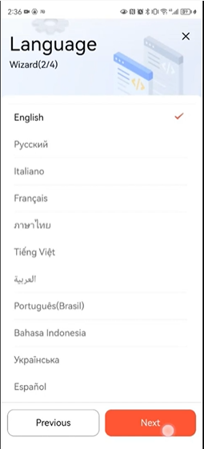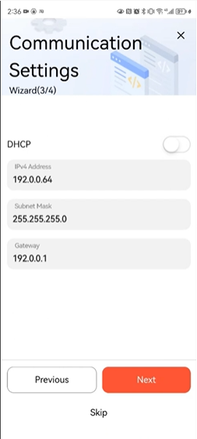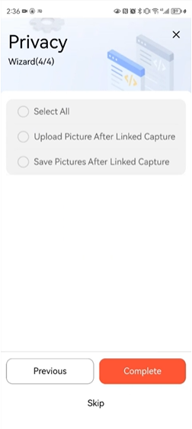

1. **Activate the Device via SADP**
   1. Run the SADP software and search the online devices. Find and select your device in online device list.

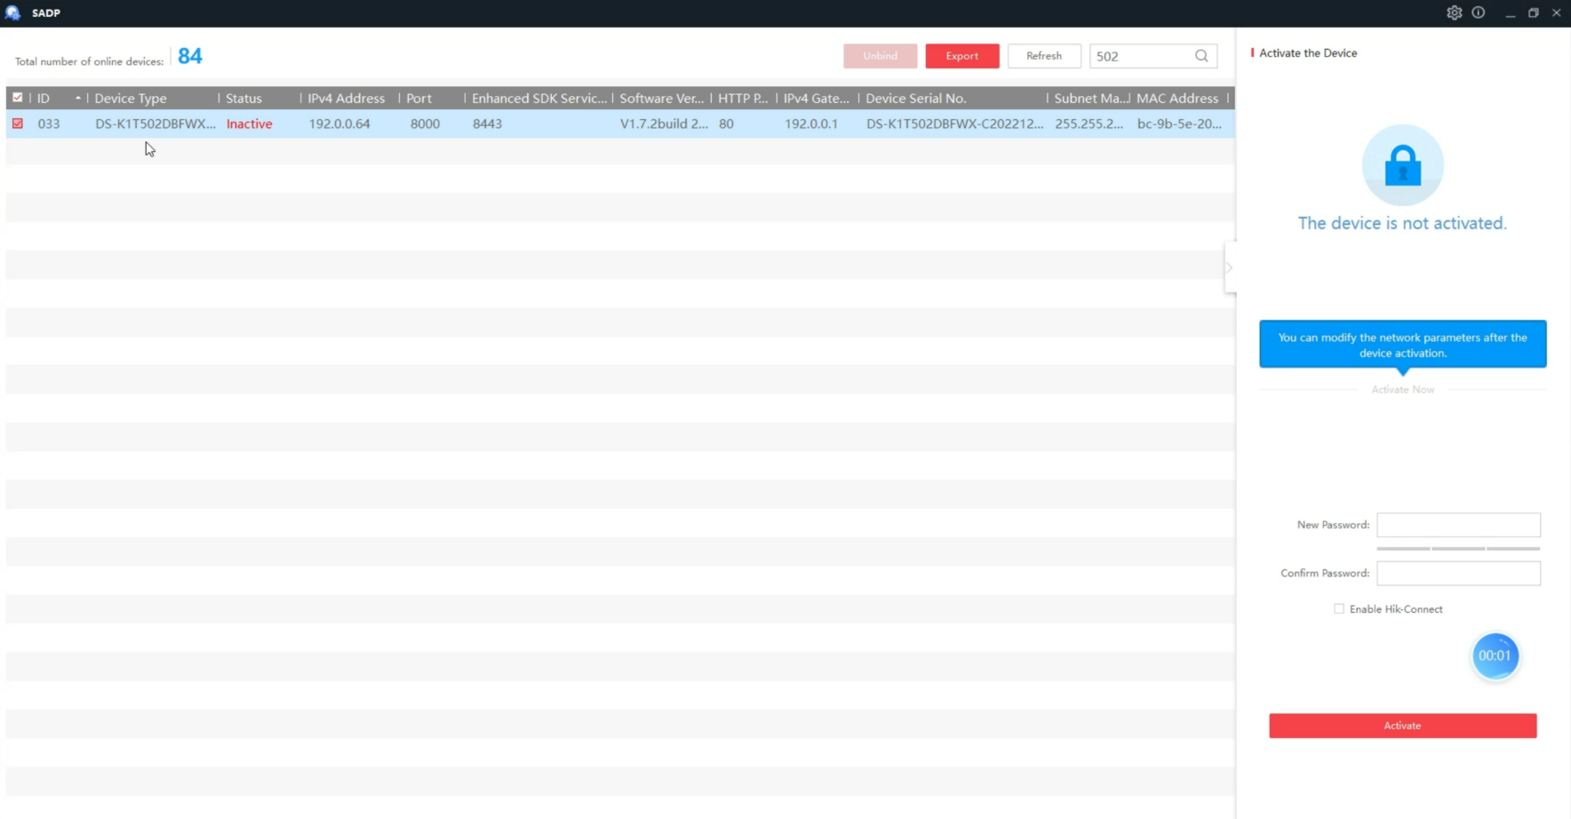

* 1. Input new password (admin password) and confirm the password. Click Active to start activation.

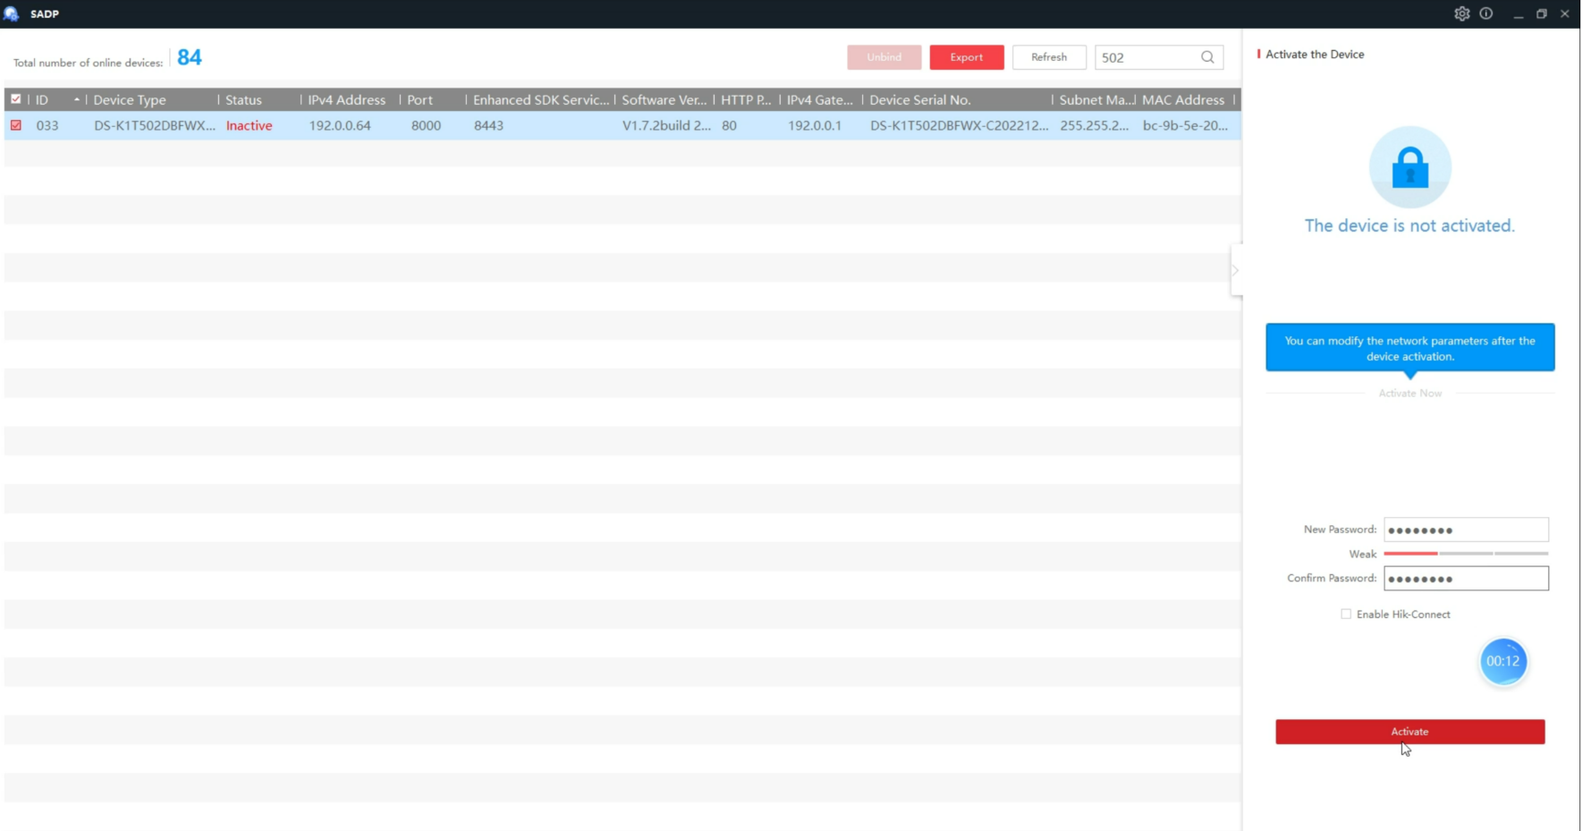

* 1. Status of the device becomes Active after successful activation.

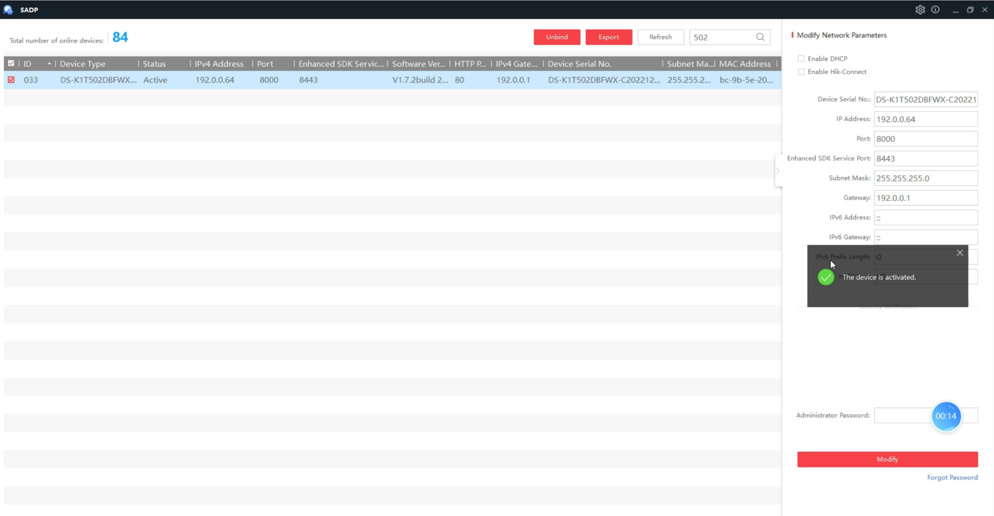

* 1. Select three questions to answer and click Confirm. (If you forget the device activation password, you can change the password via security question.)

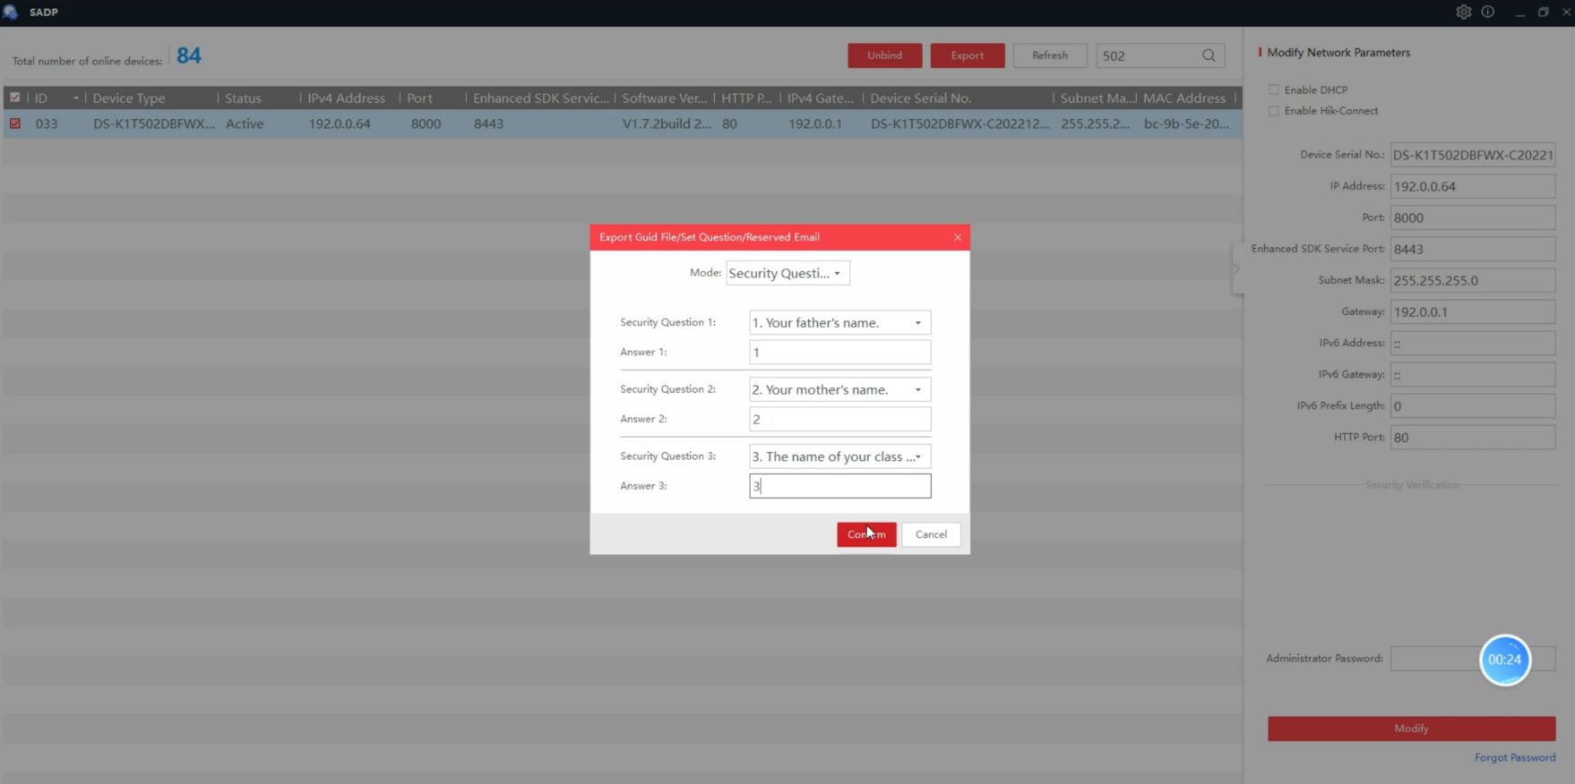

* 1. Change the device IP address to the same subnet as your computer by either modify the IP address manually or checking Enable DHCP.

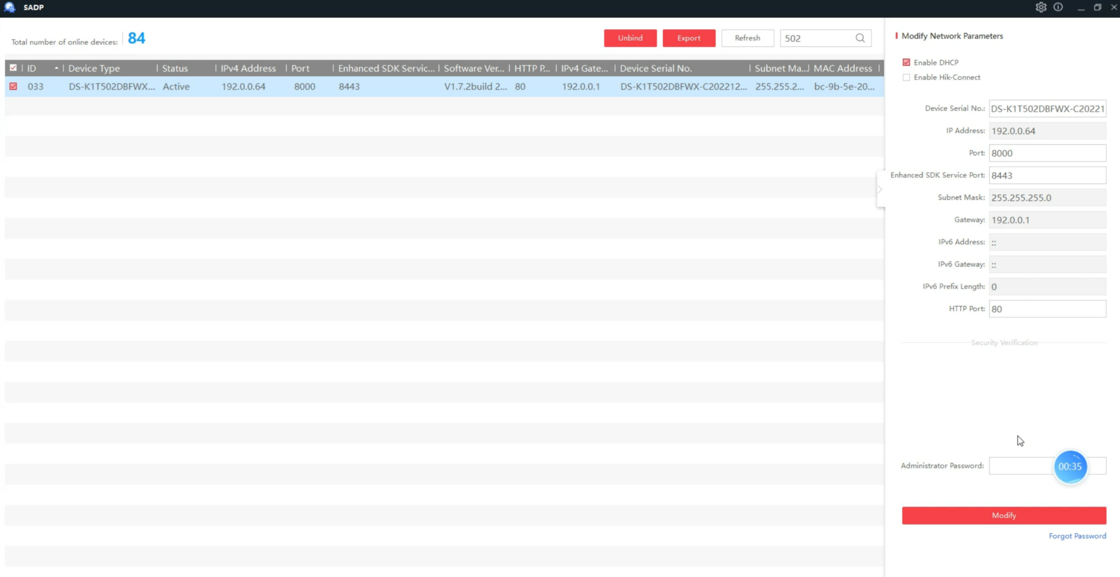

* 1. Input the admin password and click Modify to activate your IP address modification.

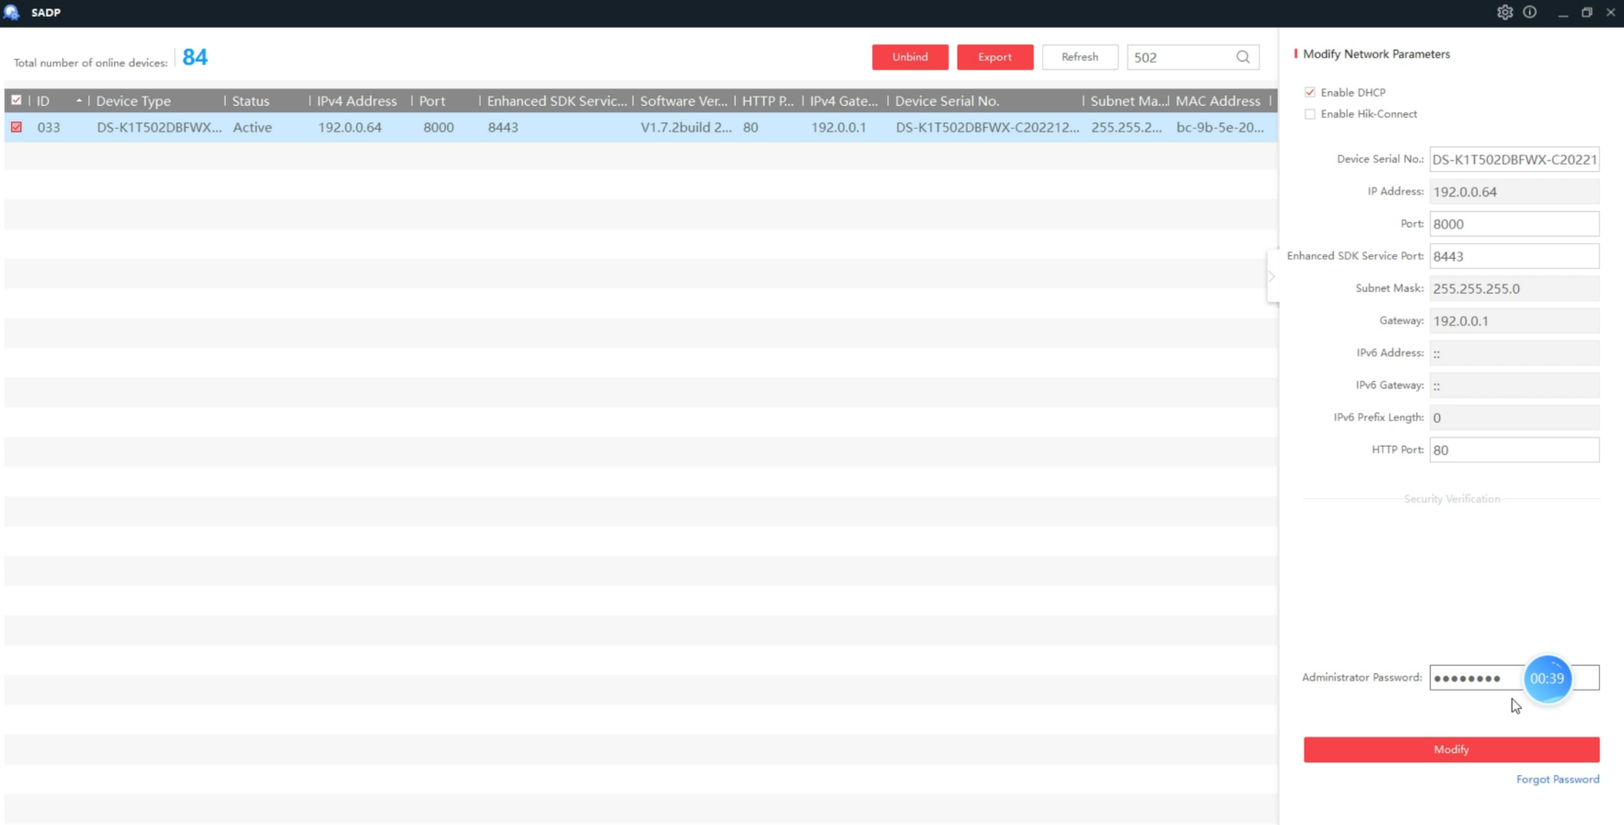

* 1. Select the device and double-click the IP address to access the Web Client.

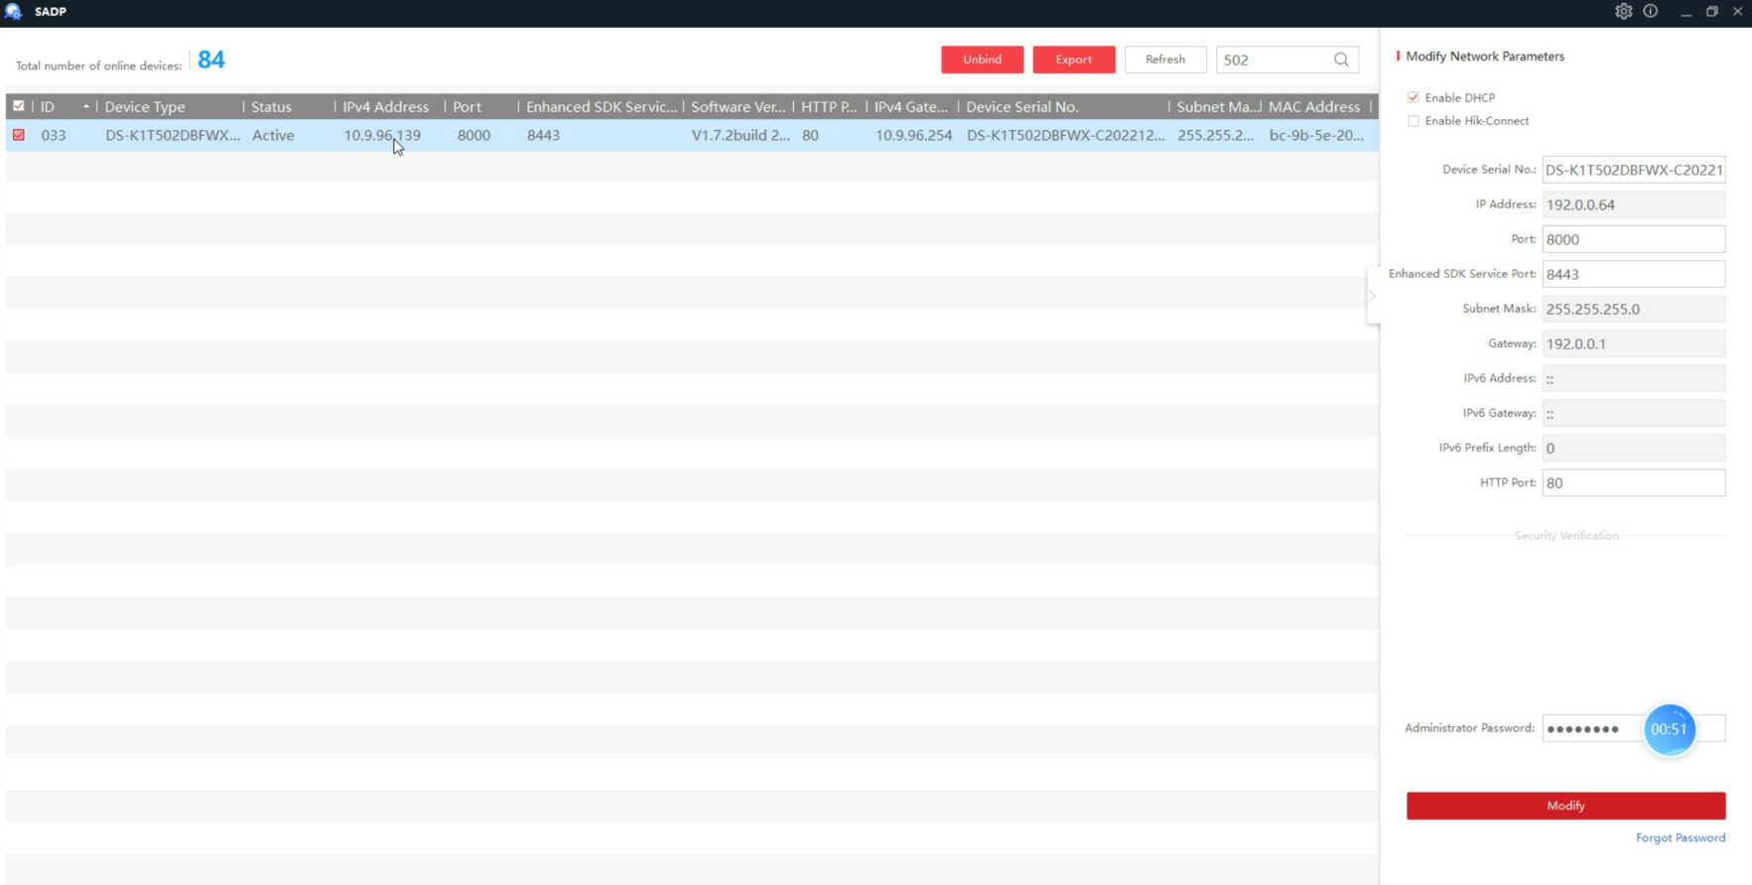

* 1. Enter the device user name and the password. Click Login.

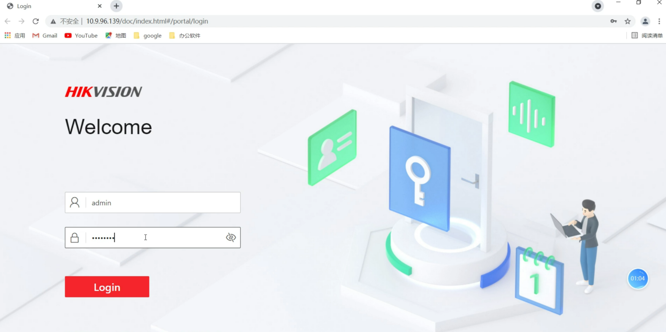

1. **Add device to HikCentral Access Control** 
   1. Enter HikCentral Access Control Web Client then choose **ISAPI** protocol and 80 port add device. 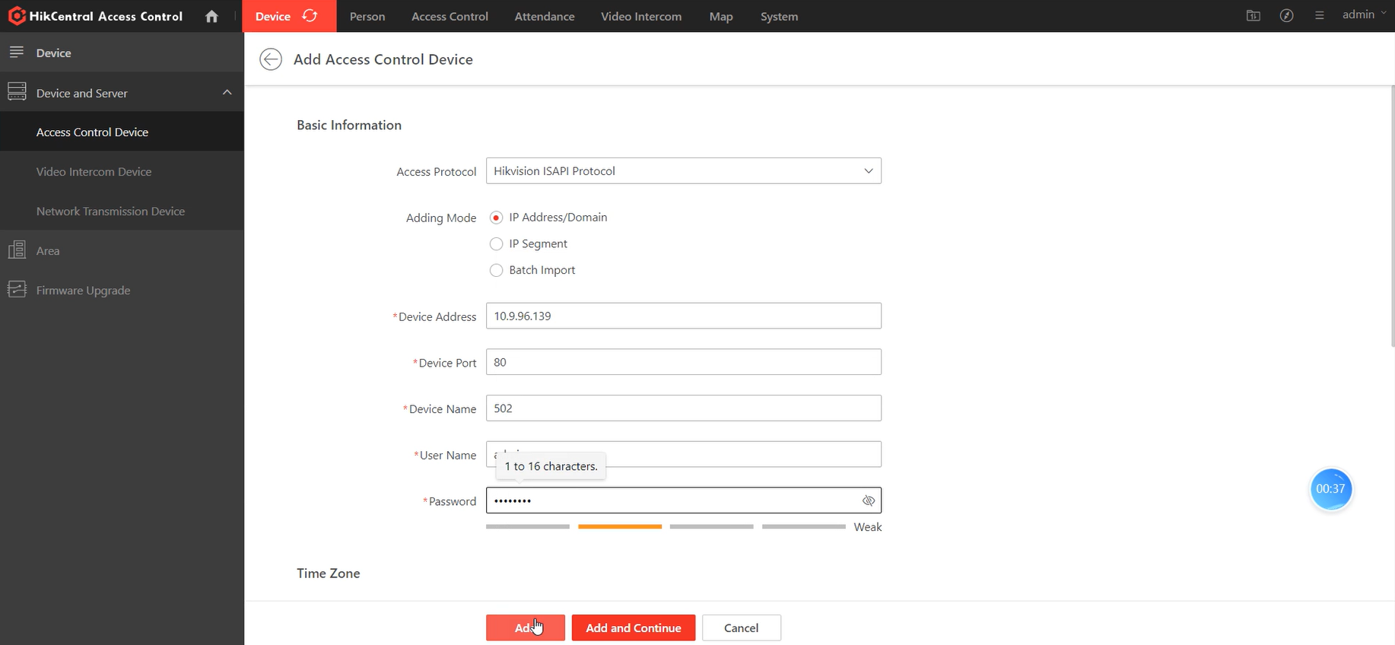
2. **Apply person to device**
   1. Create a name for the access level..

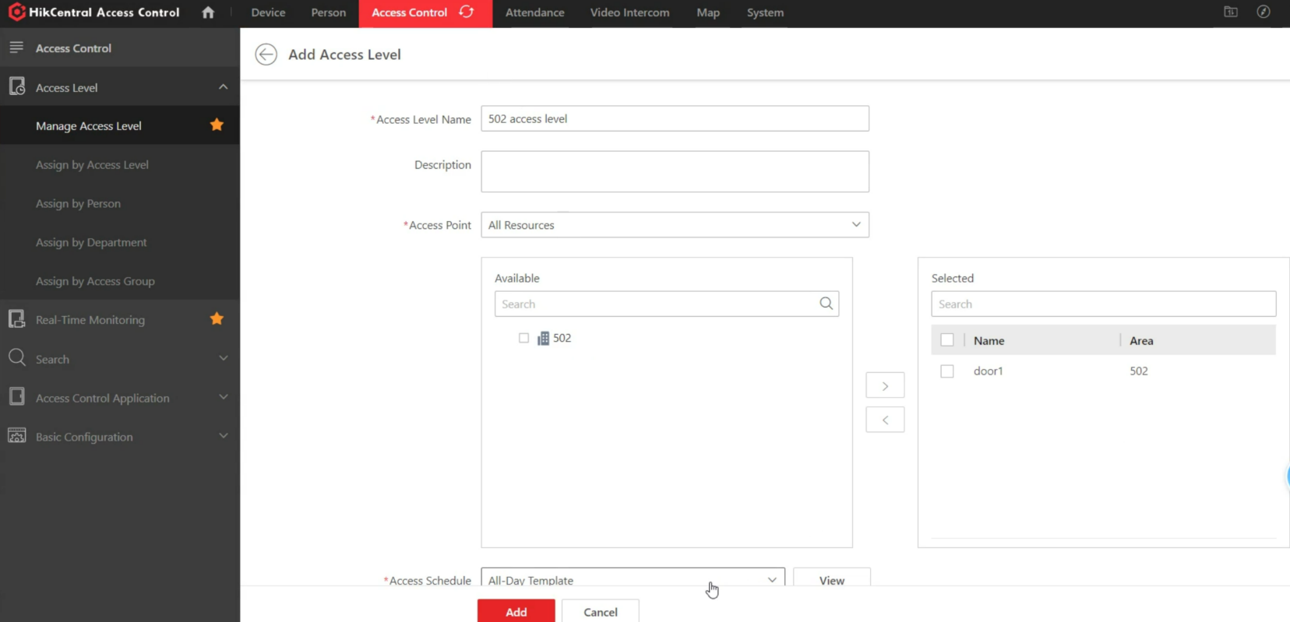

* 1. Click Add to add the access level and return to the access level management page.

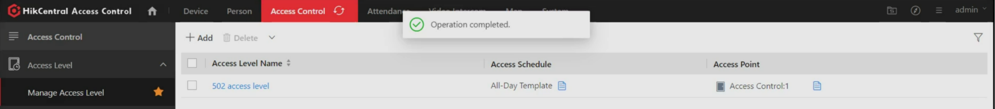

* 1. Add person info on the platform such as card number, fingerprint, pin code etc.

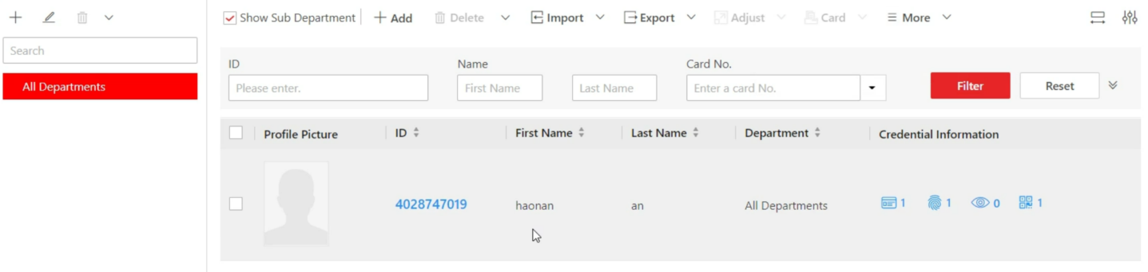

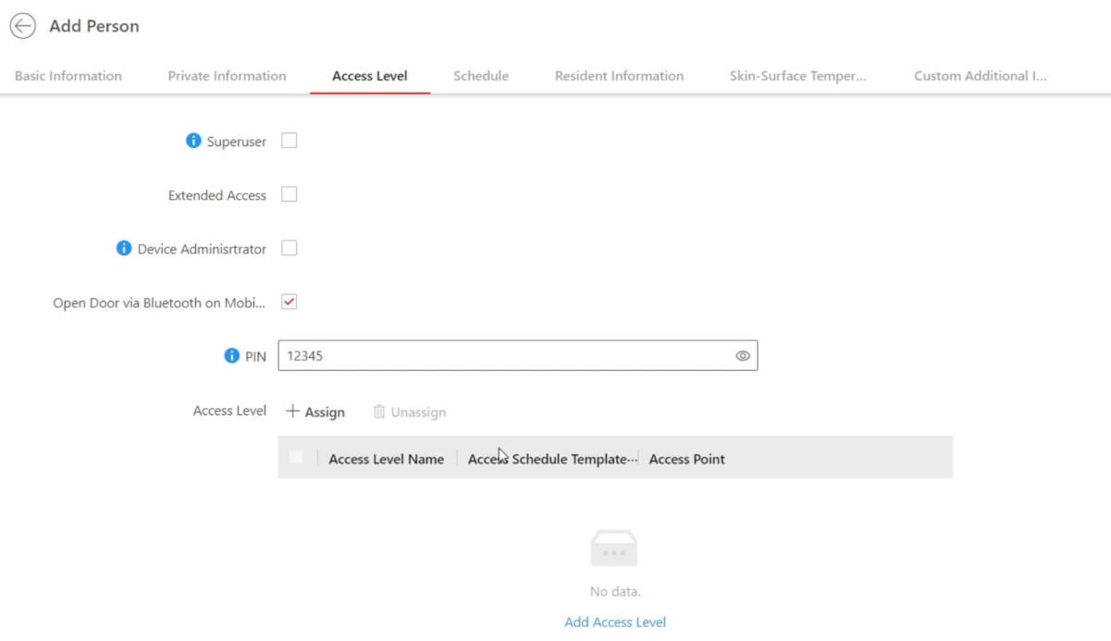

* 1. On the top, select Access Control → Select Access Level → Manage Access Level on the left → Click Add to enter the Add Access Level page.

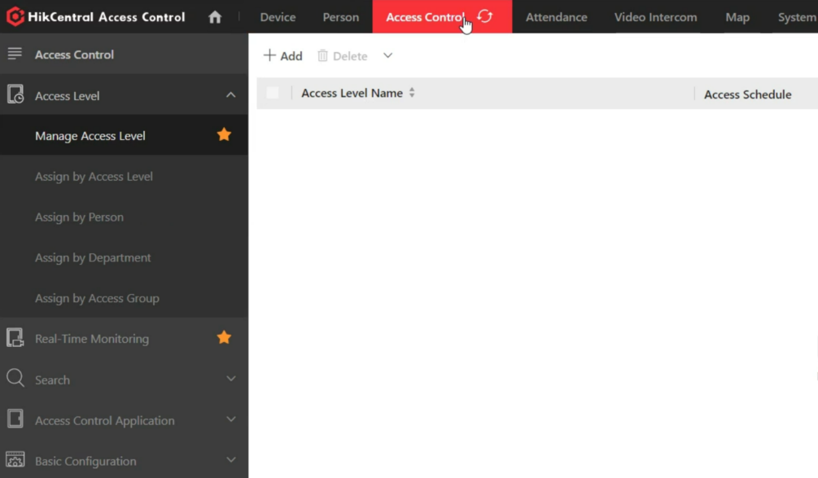

* 1. On the top, select Access Control → Select Access Level → Assign by Access Level on the left → Click on the access level that you want to assign to person.

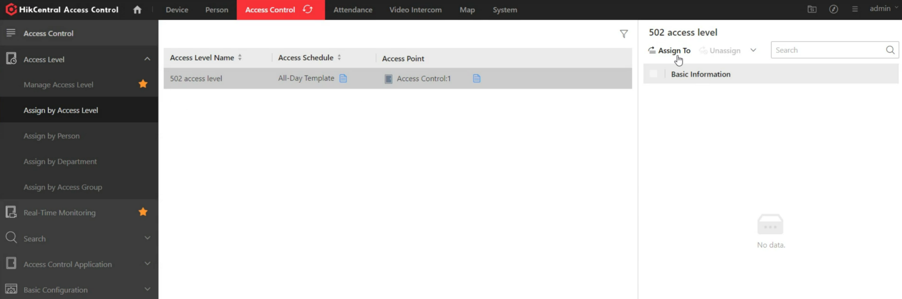

* 1. On the assignee panel, click Assign To to show person list.
  2. Select the persons whom you want to assign the access level to and click Add.

1. **Operation on device**
   1. On the top, select Device → Select Device and Server → Access Control Device on the left → Click  in the Operation column to enter the configuration page of a device.

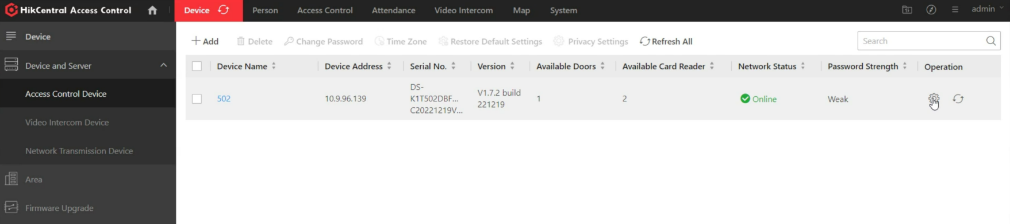

* 1. Select Configuration on the left → Select Access Control → Select Authentication Settings

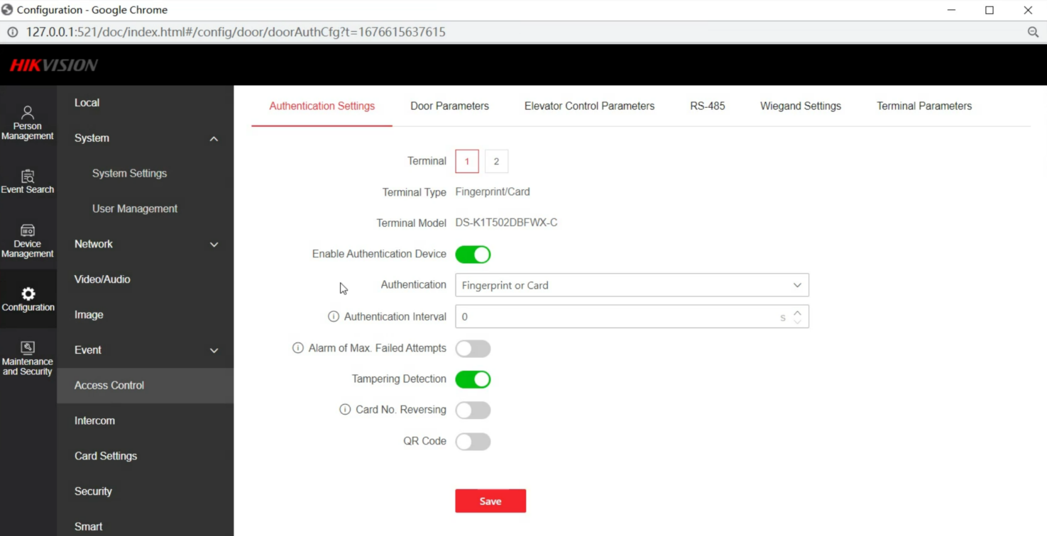

* 1. Chose Authentication method: card or fingerprint or password. Click Save.

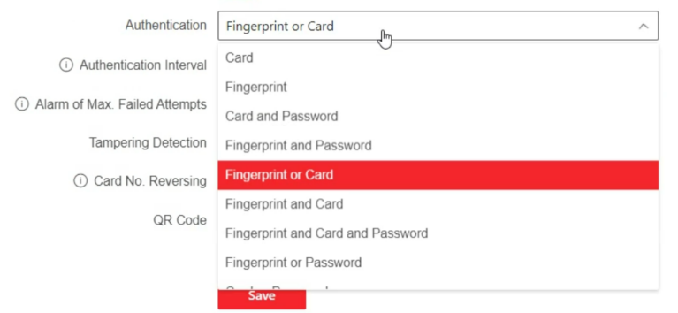

* 1. Check the authentication event on the platform real-time monitoring.

