**How to Use K1T502 Video Intercom Function**

**Preparation**

1. Power on and activate the device
2. Configure device network parameter and make sure it’s connected to the Internet.
3. Login device web interface with PC or mobile phone (device and PC/mobile phone should be in same network), or add device to HCP with ISAPI protocol, or add device to IVMS4200 with port 80 (K1T502 doesn’t support port 8000)
4. Install Hik-Connect app from app store on your mobile phone.

**How to Use K1T502 Video Intercom Function**

**Function 1: Call Hik-Connect App**

1. **Configure Hik-Connect function**
   1. Enter Configuration🡪Network🡪Device Access menu, enable function and set the verification code and click save, then click refresh until you see online status.

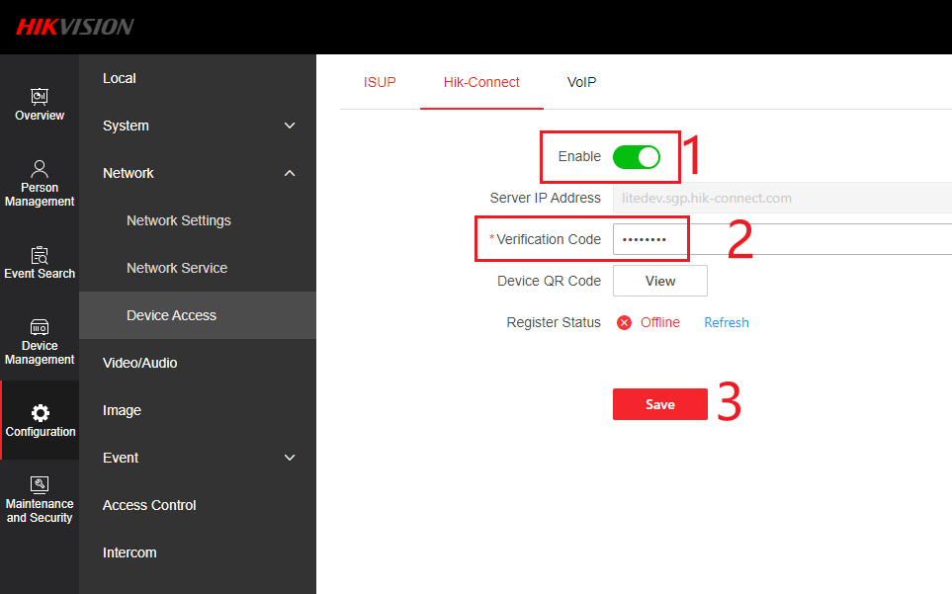

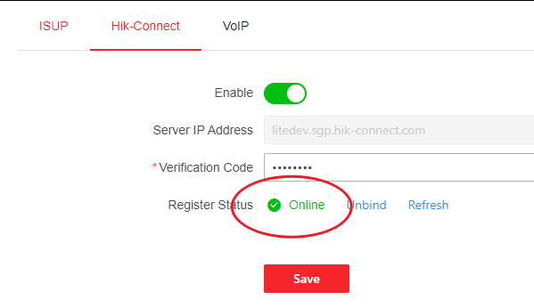

1. **Add device to Hik-Connect app**
   1. Scan the QR code in the back of device or web interface and with Hik-Connect app, or input 9 digits device serial number manually(you can find it on the web interface). and input the verification code which you configured in previous web interface

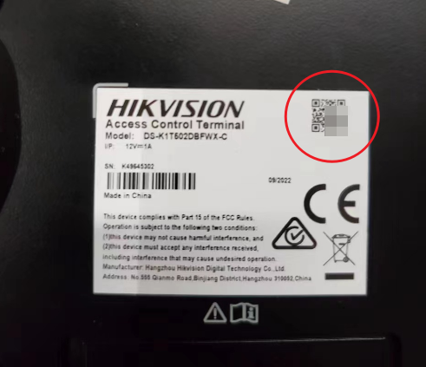 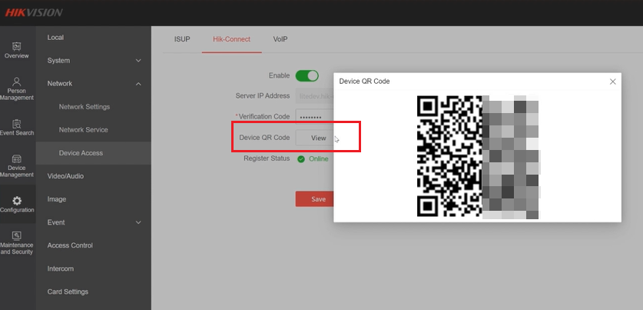

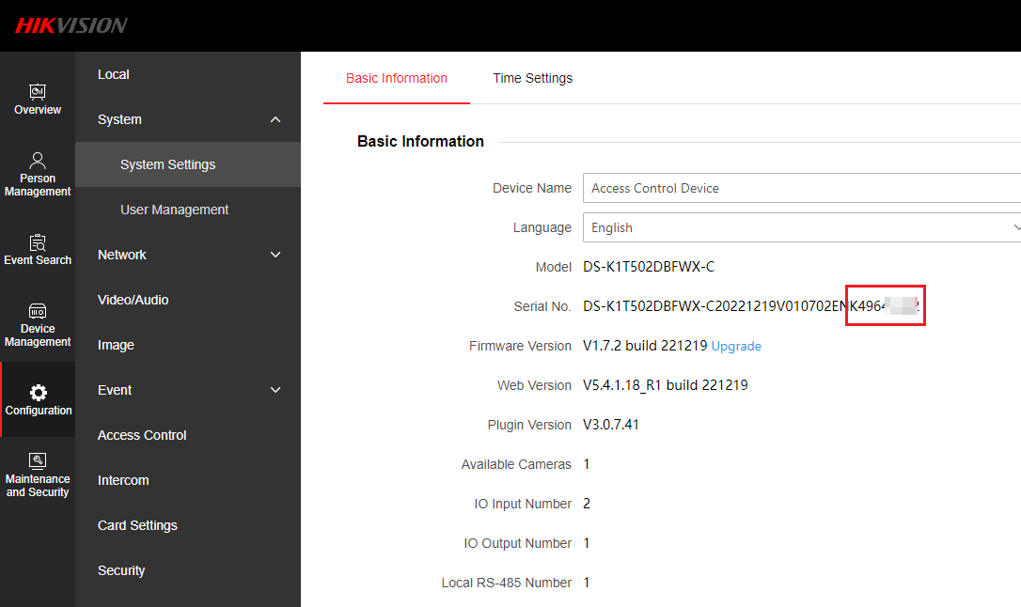

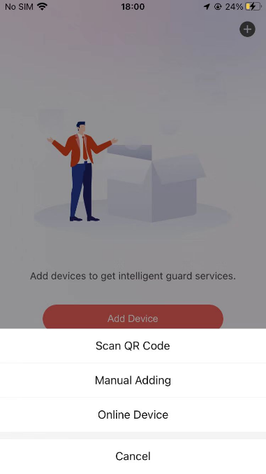 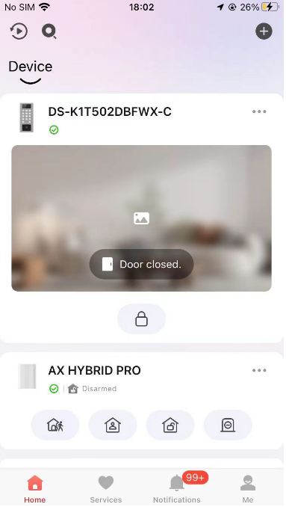

1. **Set call mode and call from device to app**
   1. Go to menu Configuration🡪Intercom🡪Press button to call, and select App

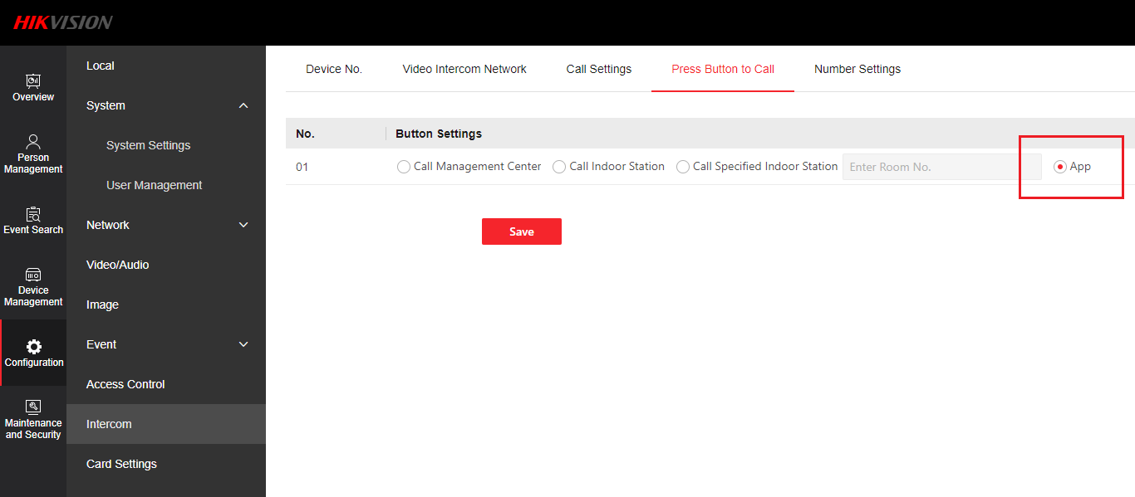

* 1. Press call button on the device and you will receive the call on mobile phone

**Function 2: Call Specified Indoor Station, Indoor Station, Main Station or HikCentral software**

1. **Set call mode**
   1. Go to menu Configuration🡪Intercom🡪Press button to call, and select call mode

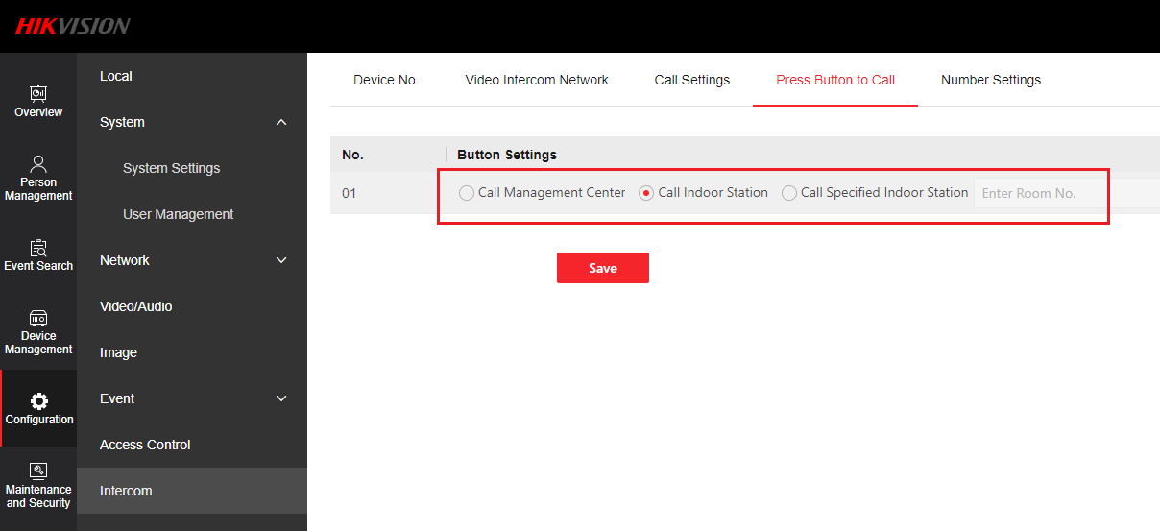

**Calling format:**

call indoor station: **room number + call button (not # key)**

call management center: **press call button**

open door with password: **password + # key**

**Note**: when set to call management center, if main station DS-KM9503 and HikCentral or iVMS software exist in the system at the same time, the call will go to main station, it has higher priority than PC software. If no main station, the call will go to PC software (HikCentral or iVMS)

**Function 3: Link with indoor station**

1. Less than 5 indoor stations

Please link K1T502 from indoor station local wizard.

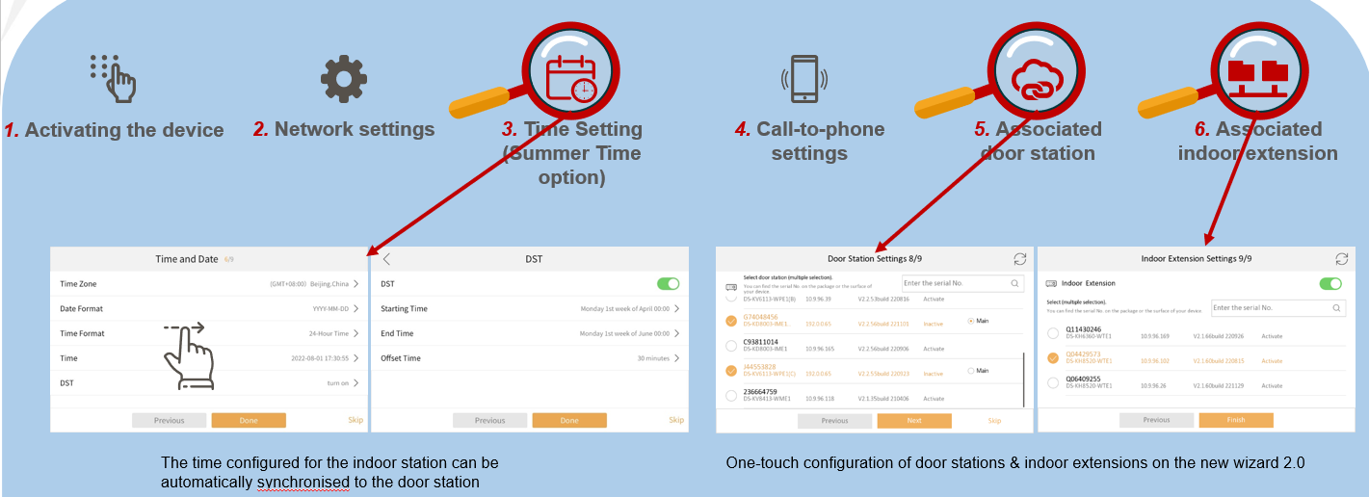

1. More than 5 indoor stations

You can link K1T502 from indoor station local wizard, same as steps in the front.

We recommend to use device import function in the web interface.

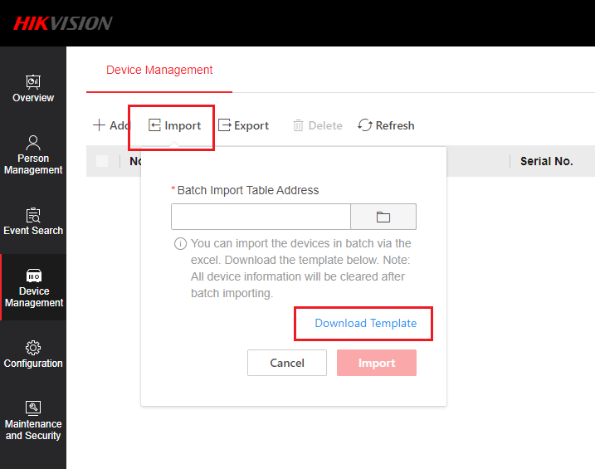

You can export device information from SADP tool or iVMS software to excel file and copy the device information and paste to the template, then import to K1T502.

