**How to use DS-K1T502 with Mobile Phone**

**Preparation**

|  |  |  |
| --- | --- | --- |
| Type | Model | Version |
| Access Control Terminal | DS-K1T502 | V1.7.2 build 221219 or later |

**How to use DS-K1T502 with Mobile Phone**

**Introduction**

When the device is not activated, we can use the device AP hotspot connection to activate the DS-K1T502 device and connect to the device WEB for configuration operation.

1. **Connection**

The Wi-Fi initial password is the device serial number, for example: K49645302.

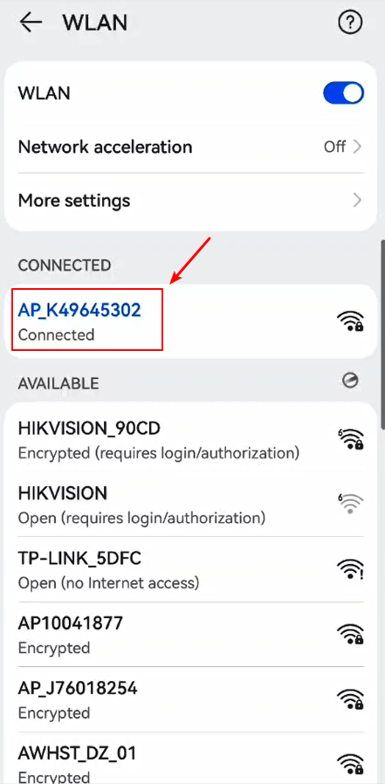

1. **Activate the device**

Activating the device requires setting a password, and subsequent connections need to use this password to connect to the hotspot.

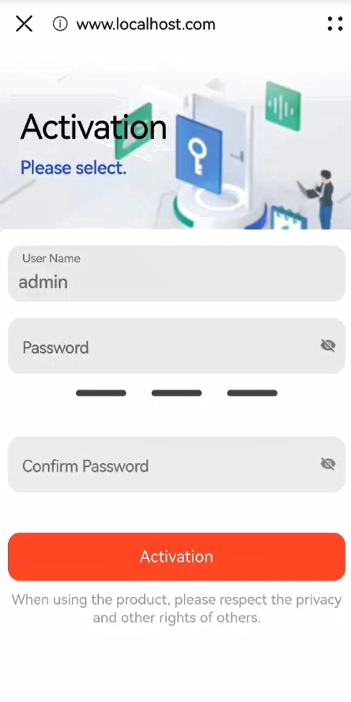

1. **WEB configuration**

You can click on Settings in the upper left corner to enter the configuration page.

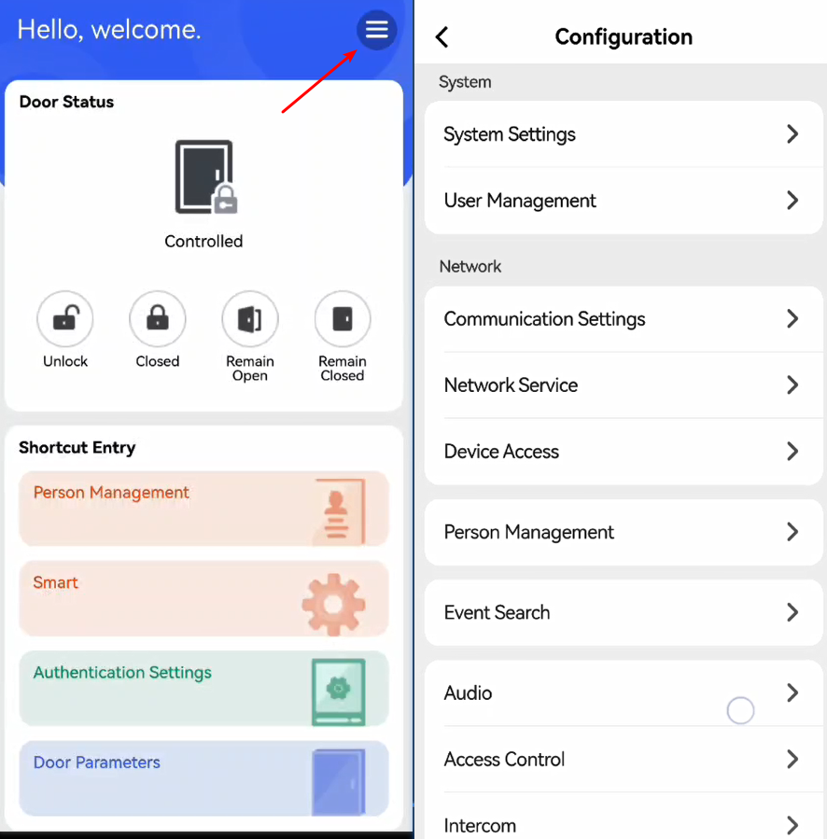

***Note:***

1. After 30 min after device powering on, the hotspot function will be disabled automatically.  
   Hold key 5 on the device keypad for 10 s to enable/disable the hotspot function.

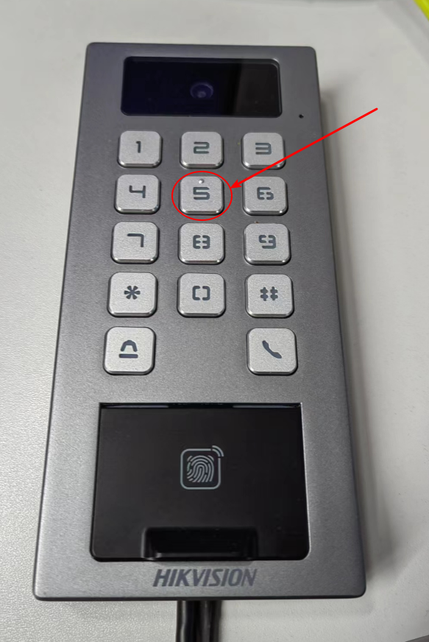

1. The default factory is to enable the AP, if not enabled, you can enable it through the browser WEB side. After device activation, the hotspot password will be changed to the device activation  
   password.

