**How to Configure Video Recording on DS-K1T502**

**Preparation**

1. TF Card. Max. 256G supported
2. DS-K1T502 Series

**How to Configure Video Recording on DS-K1T502**

1. **Install TF Card** 
   1. Install TF Card and back cover before power on device. If you install TF card when device is powered on, please reboot device

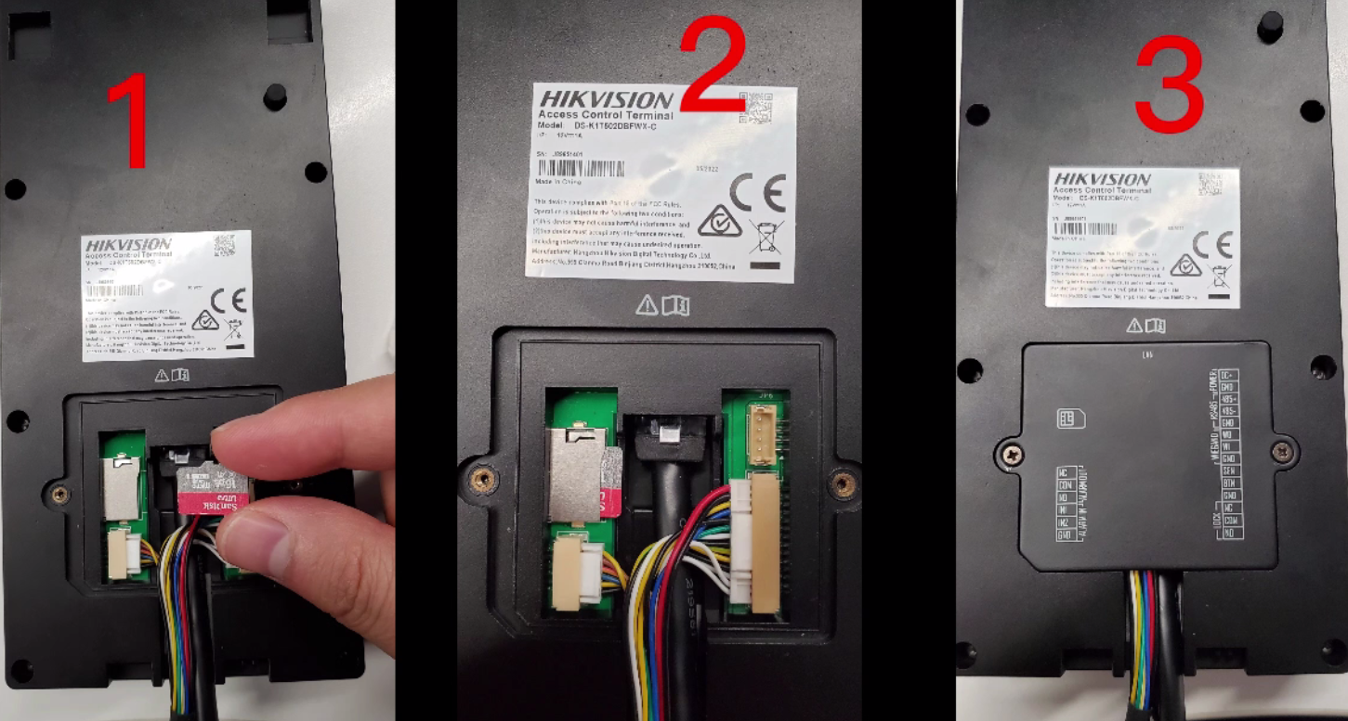

1. **Configure Event Linkage** 
   1. Log in device web page.

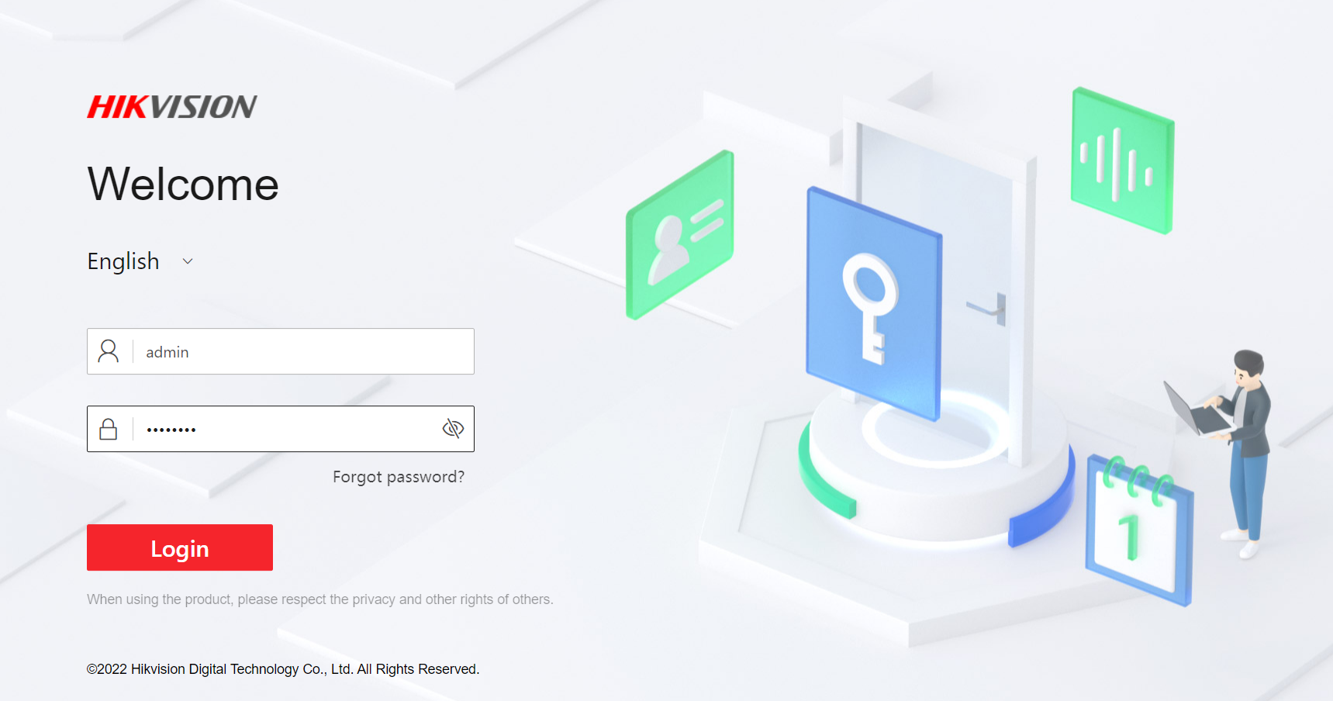

* 1. Go to configuration->Event->Event Detection-> Linkage Settings, click Add, then you can add new event and card linkage. Set trigger event according to your actual need, here we take door open event for example

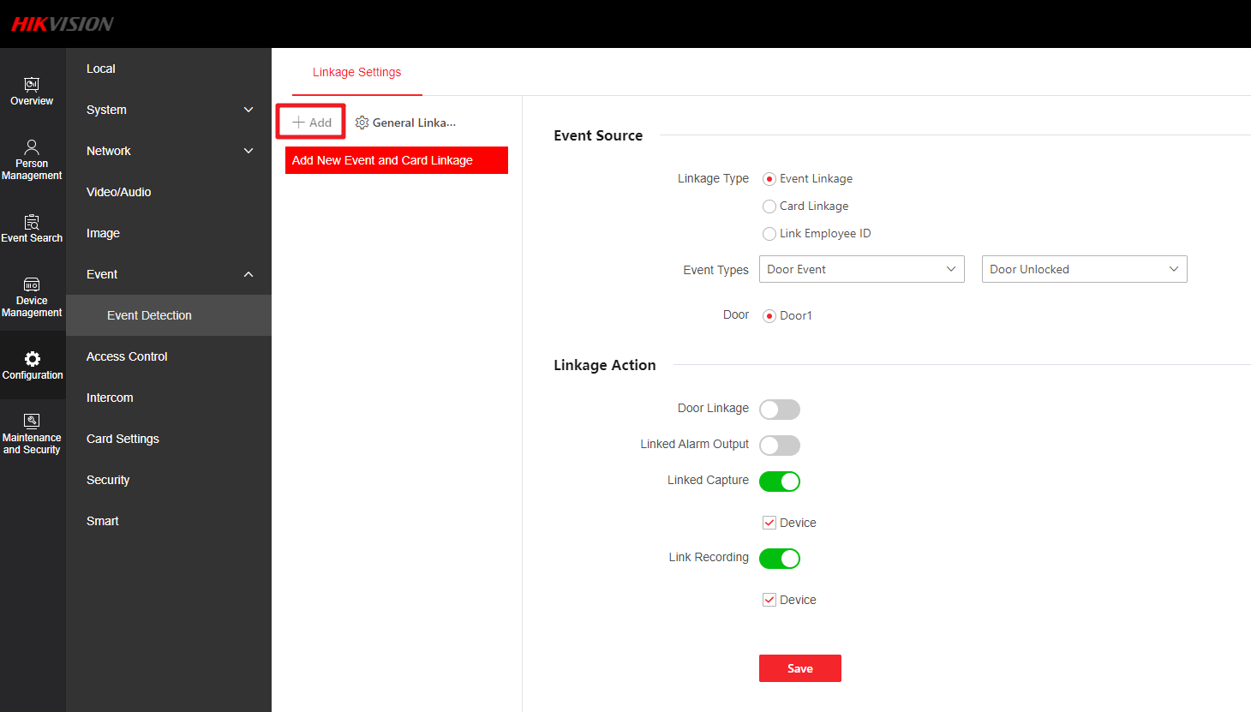

* 1. Click General Linkage Settings to set recording time and recording delay. Then linkage setting is finished.

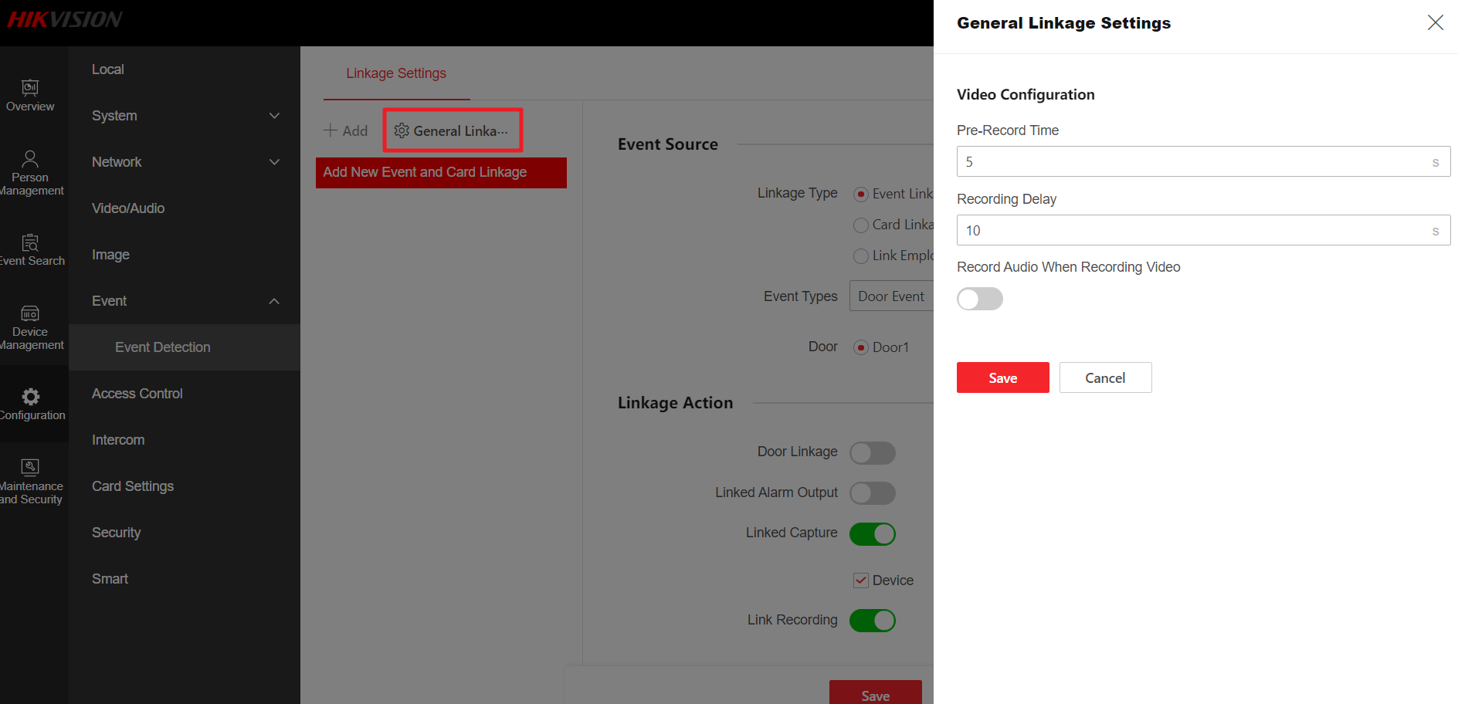

1. **Check recording video**
   1. Go to Event Search, you can select ‘View event with recorded video’ option to search for video.

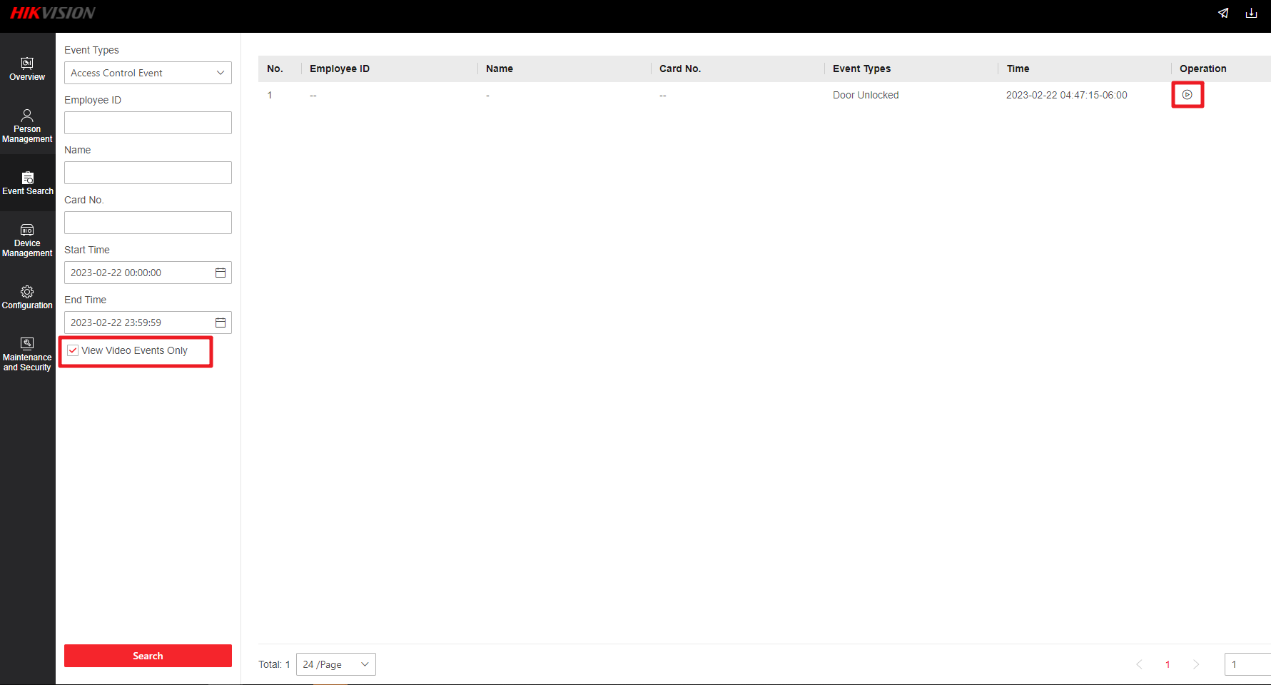

* 1. Click the ‘play’ icon at the end of event , you can check recorded video

