**How to Use DS-K1T502 to Open Door via QR Code**

**Preparation**

1. DS-K1T502 device
2. Computer running HikCentral AC or HikCentral Professional

<https://www.hikvision.com/en/support/download/software/>

**How to Use DS-K1T502 to Open Door via QR Code**

1. **Generate QR Code**
   1. Log in web page of HCAC, add device in Device module.

For DS-K1T502, choose Access Protocol as Hikvision **ISAPI** Protocol and Device port as **80**

For other access control device, choose Hikvision Private Protocol and 8000 port

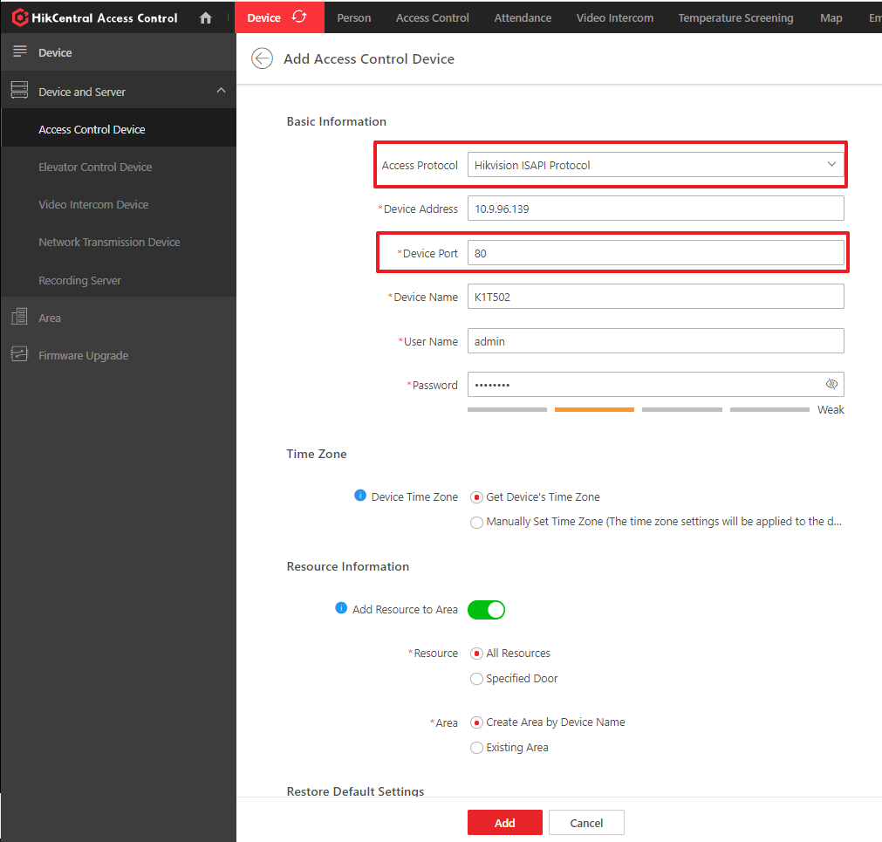

* 1. Go to Person module, add a person. Click ‘Credential Management’ to collect card number. If there is no real card, you can input a random number within 20 digits, for example: 12345678

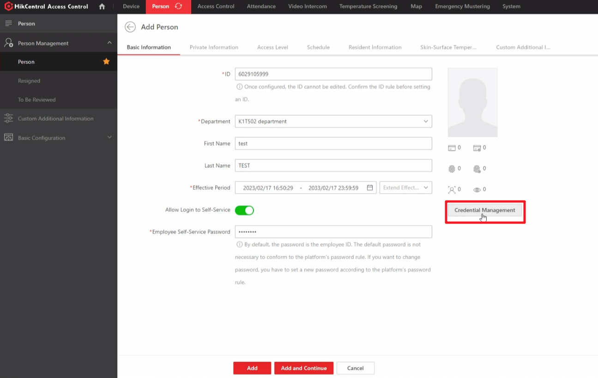

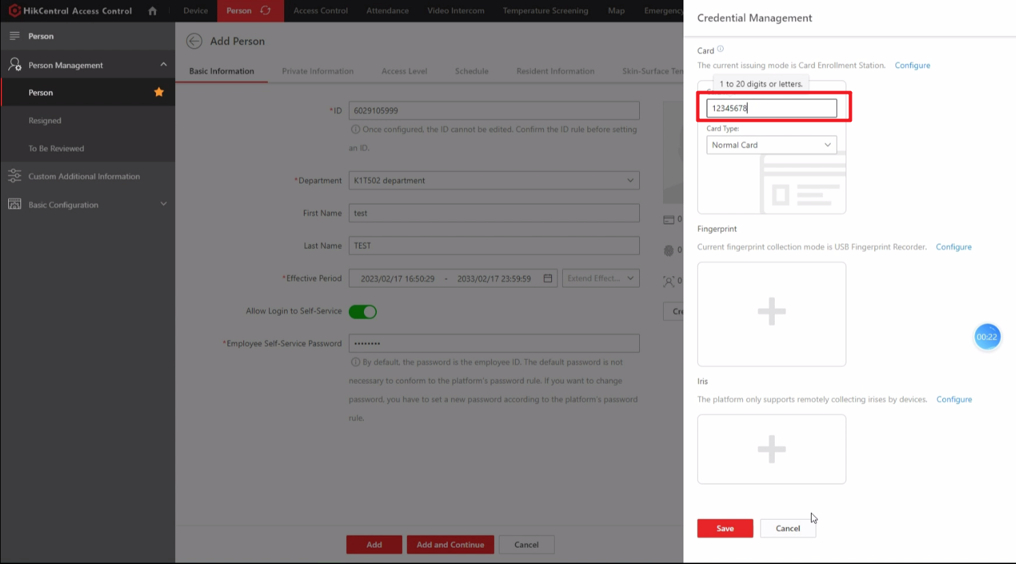

* 1. After creating a person, you can check QR Code in person module. Click Download to download QR Code

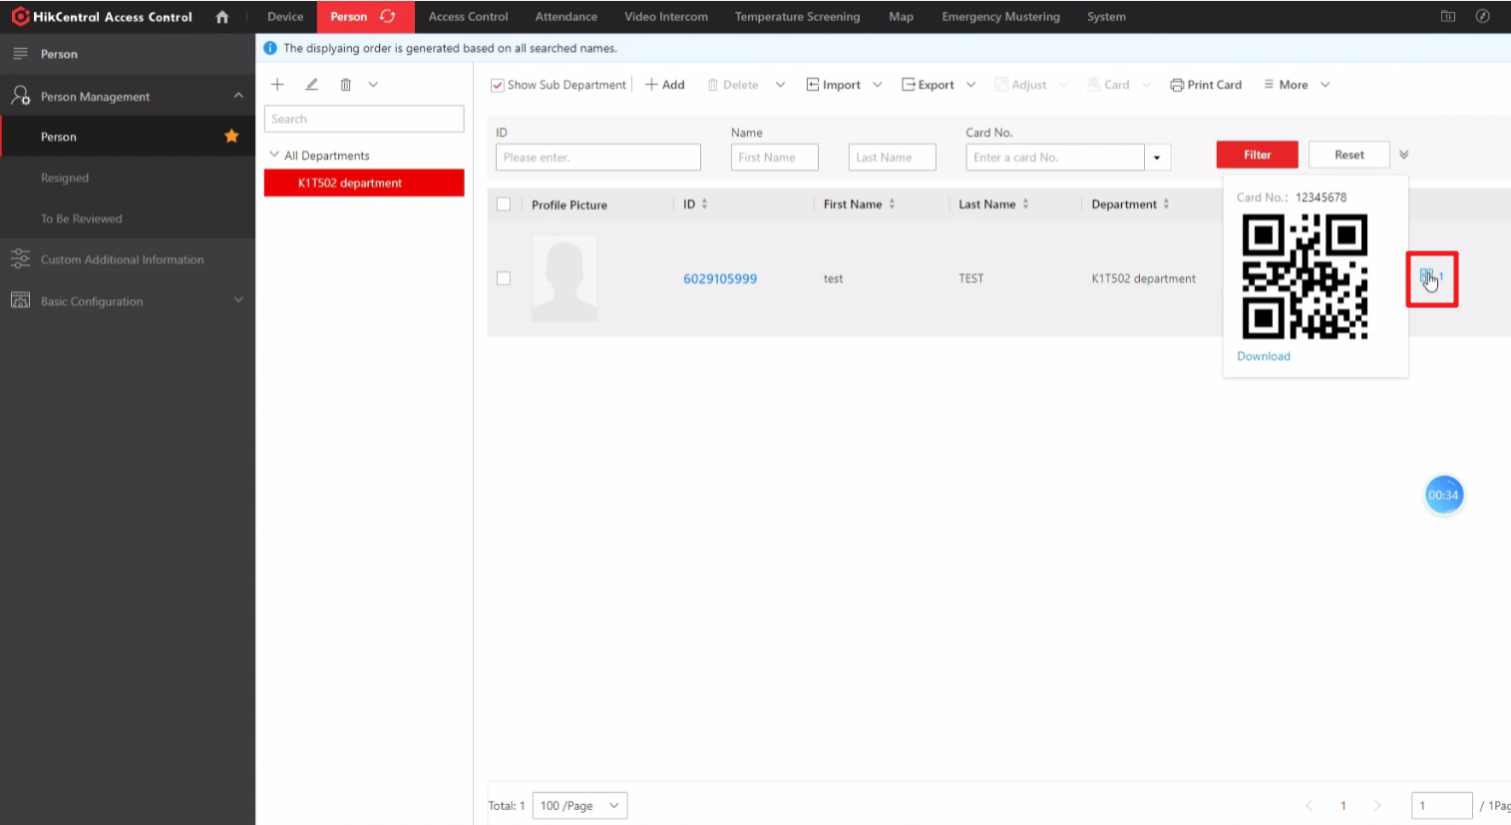

1. **Set Access level**
   1. Go to Access module, set access level for K1T502, and assign access level to the person created in step 1, then software will apply person and card number to K1T502 device automatically.

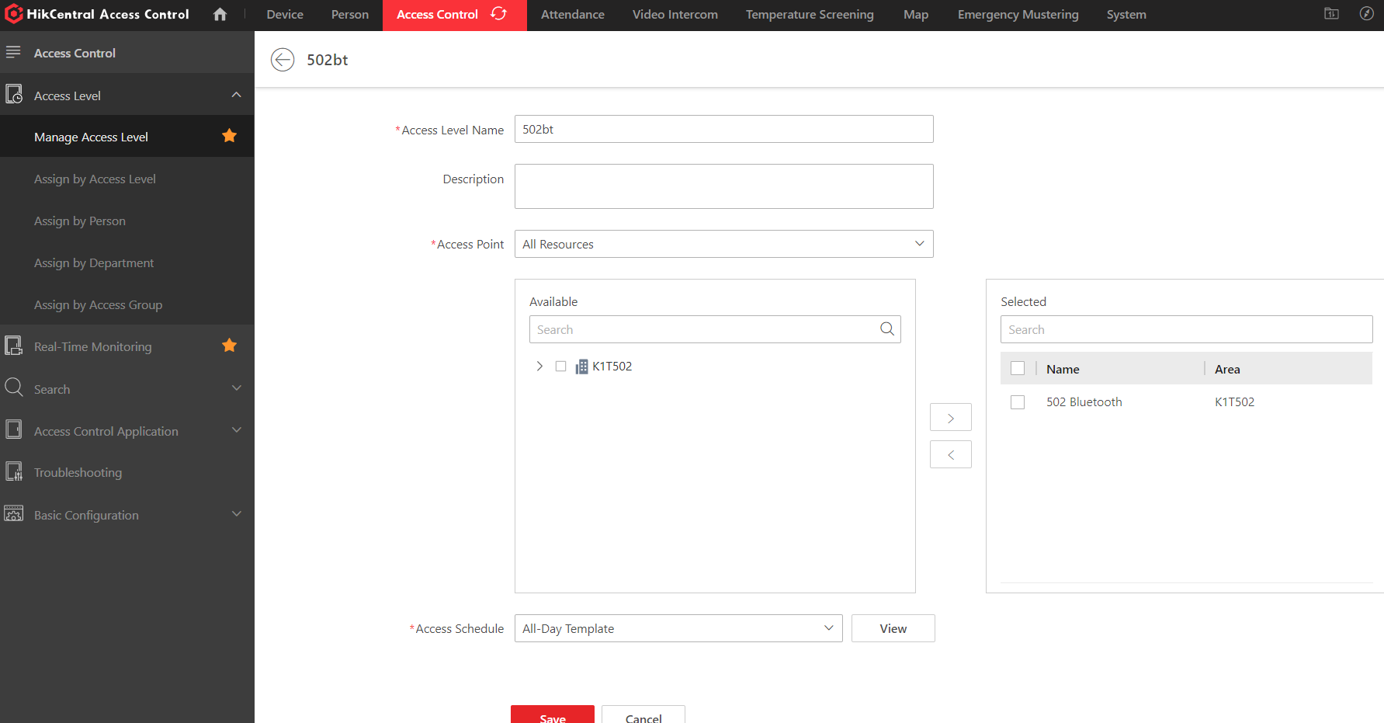

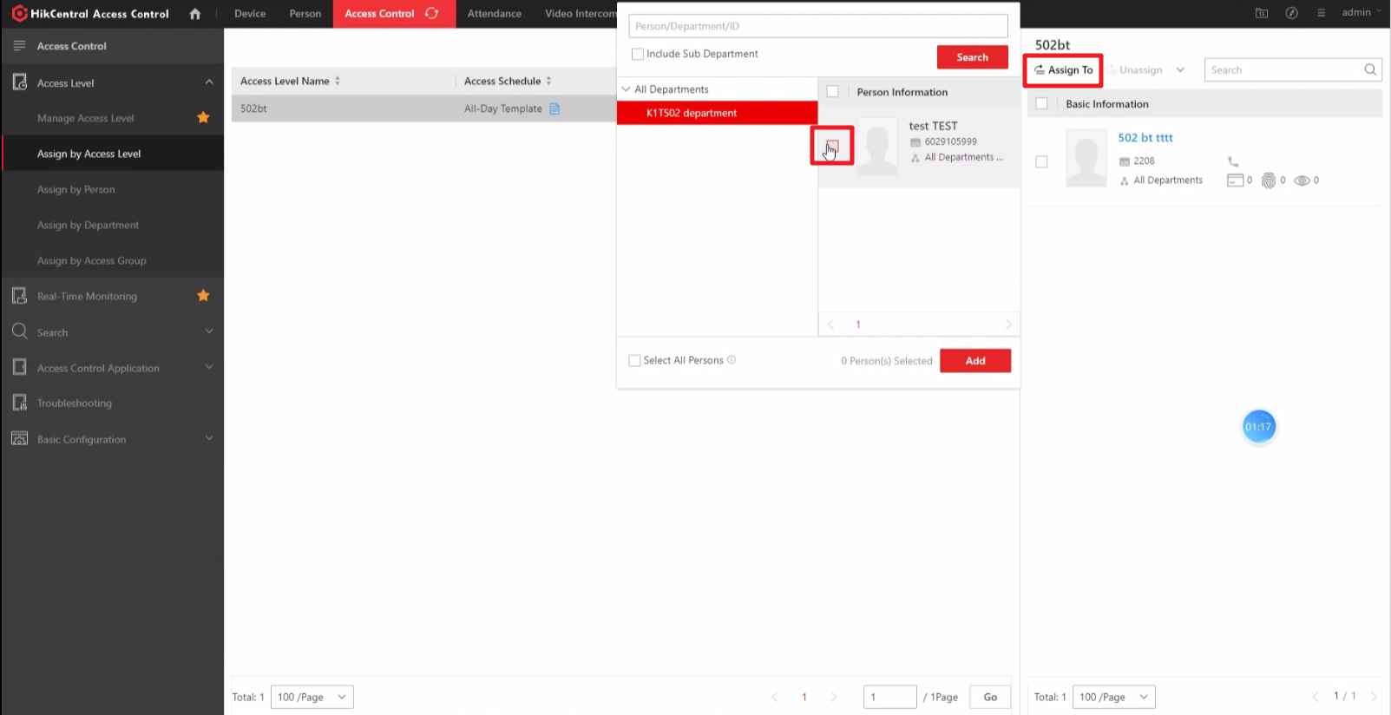

1. **Enable QR Code Function of DS-K1T502**
   1. Enable QR Code function of DS-K1T502. Log in web page of DS-K1T502, go to Configuration->Access Control->Authentication Settings, Enable QR Code function

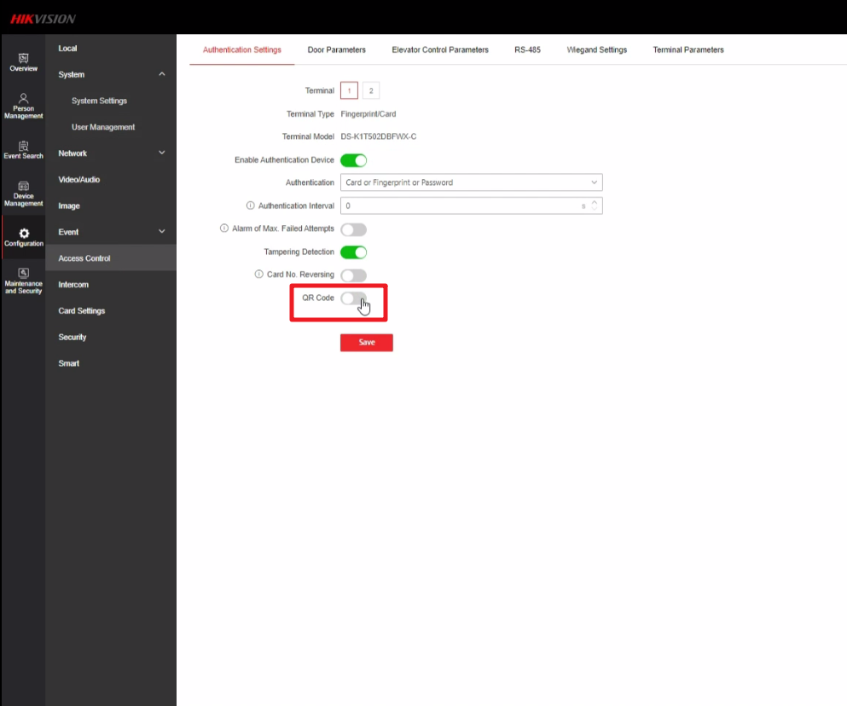

1. **Open door via QR Code**
   1. Prepare QR Code. Print QR Code or display QR Code on a screen with size no less than 6*6 cm. Put the QR Code in front of device camera within distance range from 13~25cm.

