**How to Use DS-K1T502 to Open Door via Bluetooth**

**Preparation**

1. Access device supporting Bluetooth function(DS-K1T502 in this document)
2. Mobile phone supporting Bluetooth and installed with HikCentral AC APP(later than V2.0.0)

You can download from <https://appstore.hikvision.com/>

1. Computer running HikCentral AC, you can download from <https://www.hikvision.com/en/support/download/software/>

**How to Use DS-K1T502 to Open Door via Bluetooth**

1. **Add device to HCAC** 
   1. Log in web page of HCAC, add device in Device module.

For DS-K1T502, choose Access Protocol as Hikvision ISAPI Protocol and Device port as 80

For other access control device, choose Hikvision Private Protocol and 8000 port

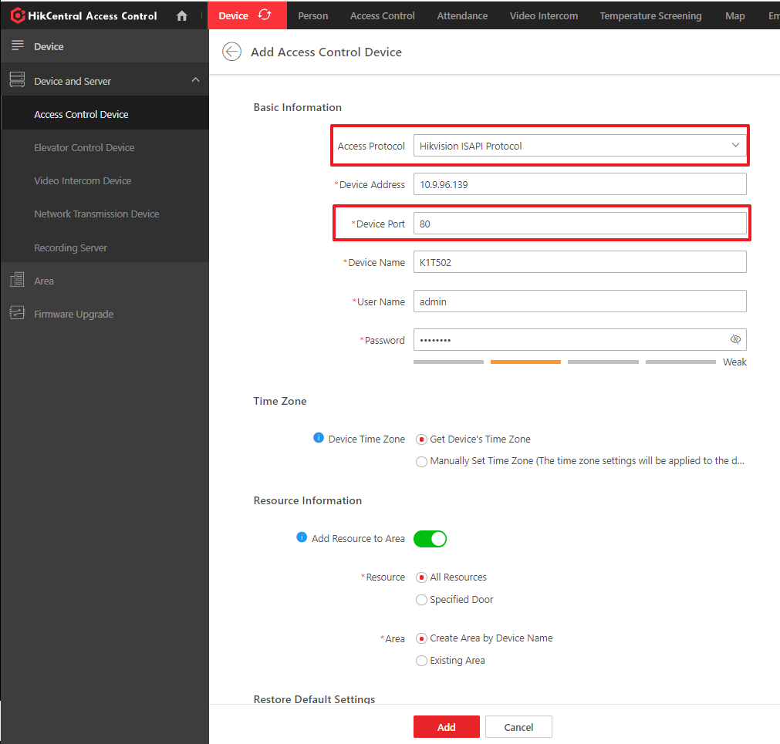

* 1. Go to Area, modify door’s name

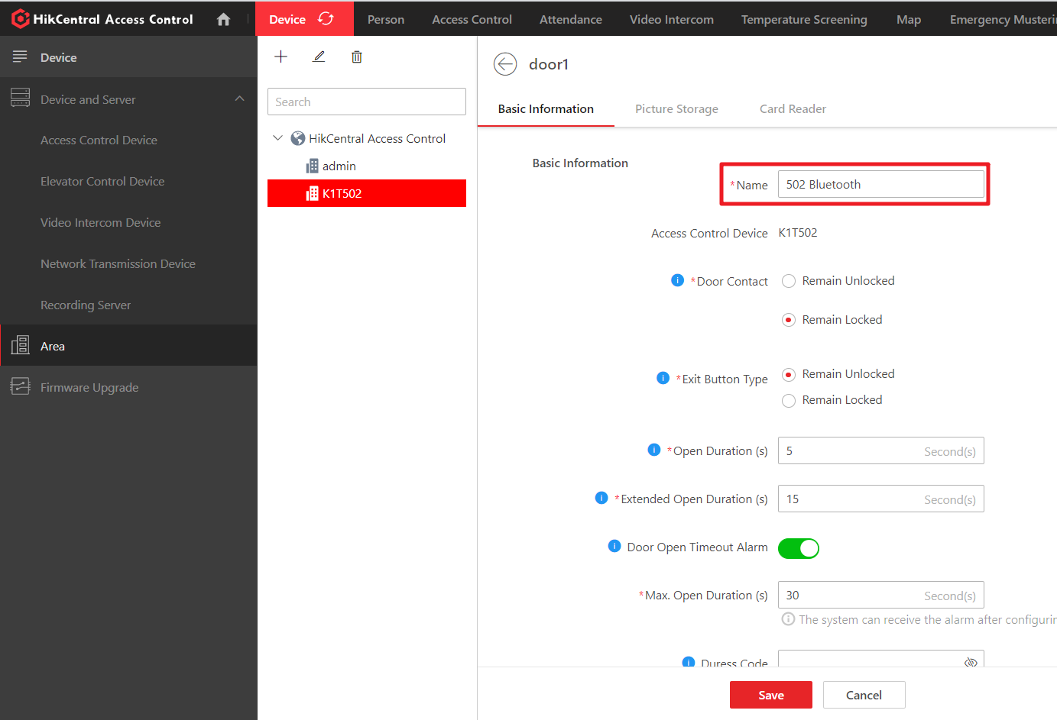

* 1. Go to System>Maintenance>Door, choose device and check open door via bluetooth enabling status. This function need to be enabled.

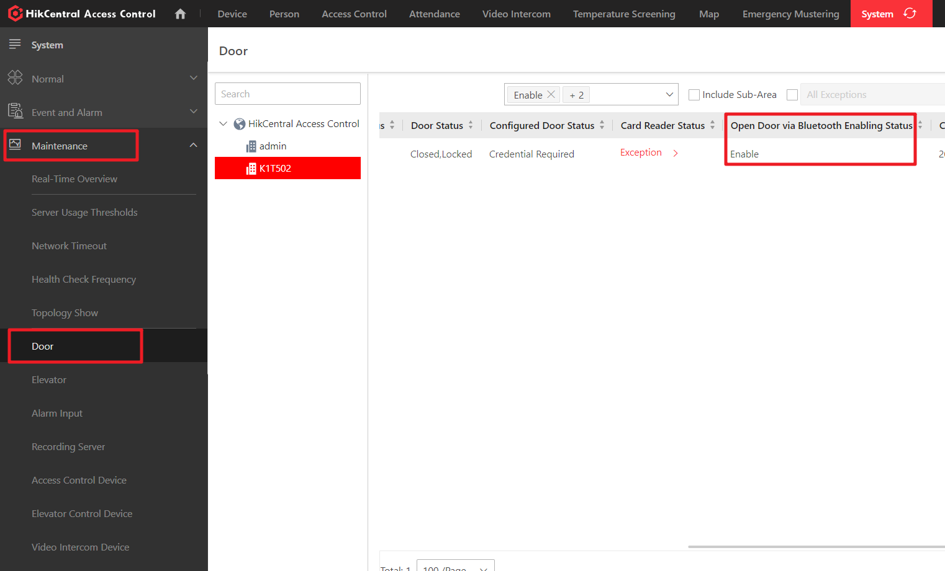

1. **Set Access level** 
   1. Go to Person module, create a person, enable **Open Door via Bluetooth on Mobile client**

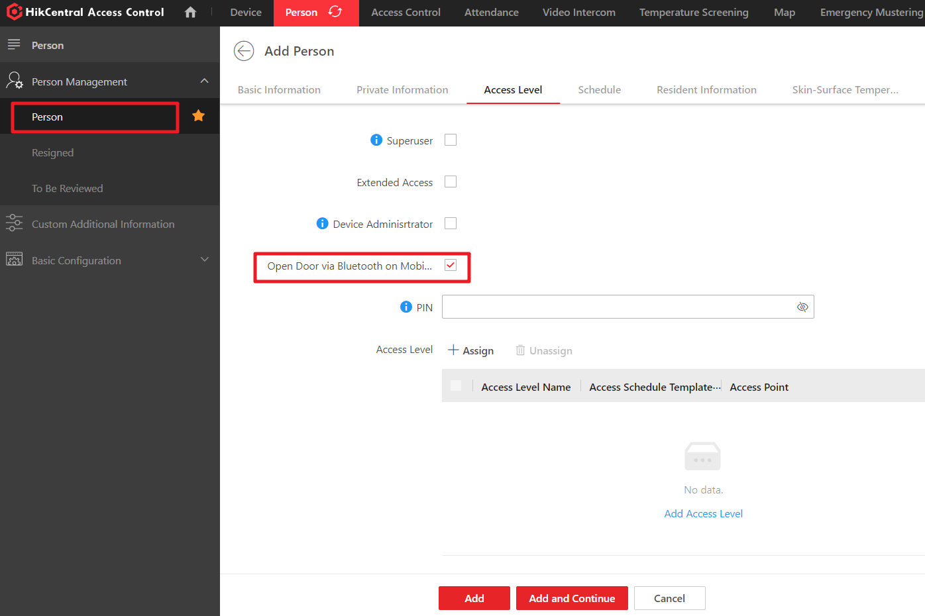

* 1. Go to Access module, set access level for K1T502, and assign access level to the person who enable Bluetooth function

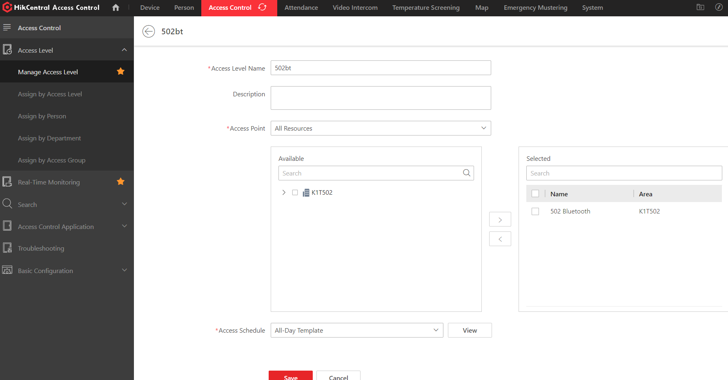

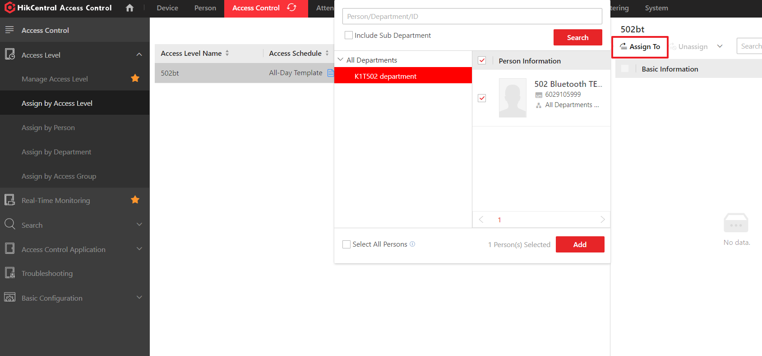

1. **Set Bluetooth work mode**
   1. Go to Access control-> Basic Configuration-> General->Open Door via Buetooth, you can choose the following mode: Auto open door or open door manually. And you can set allowed distance to open door when in auto open door mode.

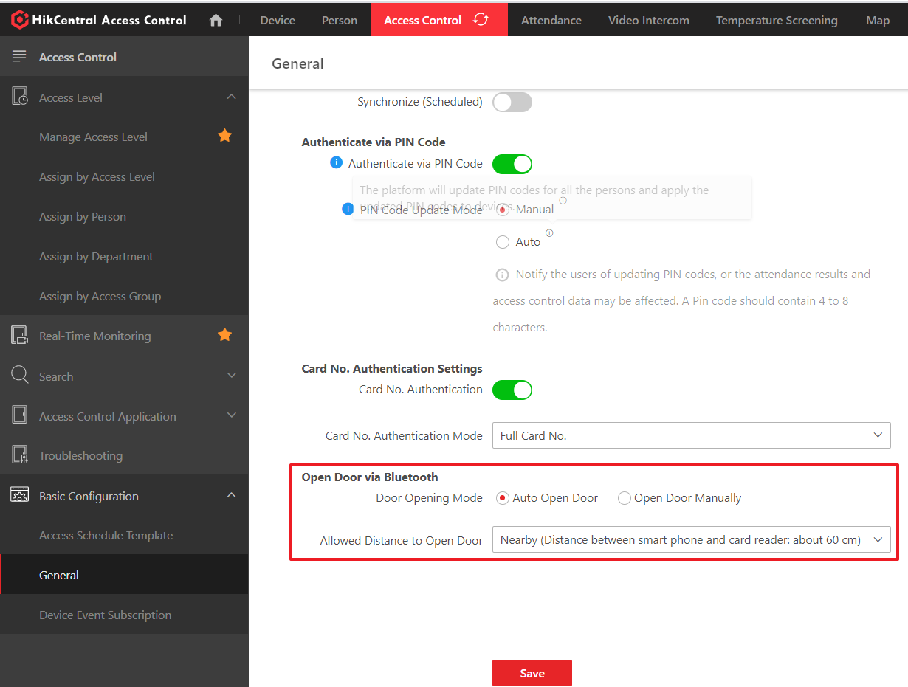

1. **Open door via HCAC APP**
   1. Make sure mobile phone is in the same network with computer which running HCAC. Open HCAC APP, log in with the following information

**Server**:

Server: by default is IP address of computer running HCAC

Port: by default is 80

**Self-Service**

Employee ID: employee id of the person applied to device

Password: by default is employee id, change password after first time login

* 1. After login, you can use HCAC APP to open door .if in auto open door mode, when APP is running and device is in distance, APP will search door and open door automatically

***Note:***

Performance of auto mode can be effected by phone model and environment, it is more recommended to use manual mode to open door

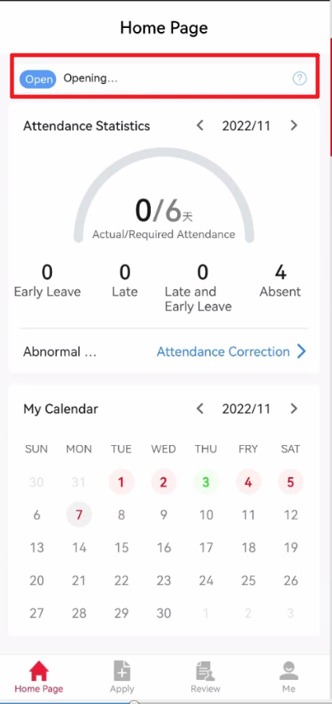

* 1. If in open door manually mode, click the ‘key’ icon, select door and click ‘Open Door’, you can open door via Bluetooth successfully

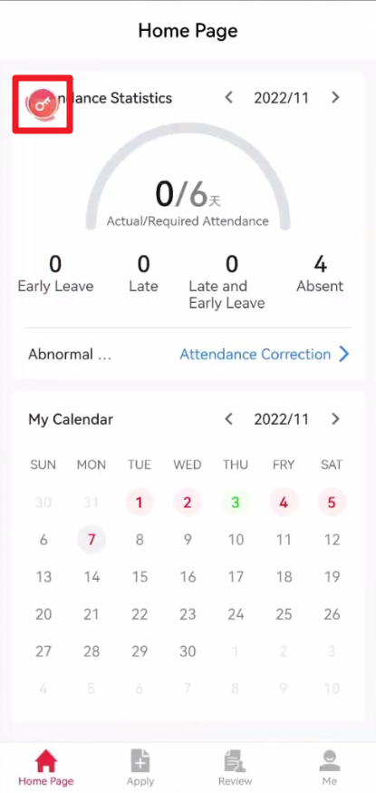 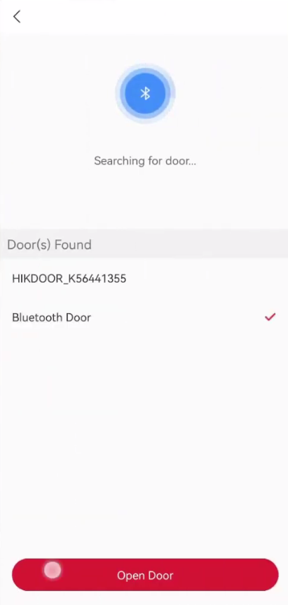

***Note:***

You can check steps through video with this link: <https://youtu.be/fZfNGaw70mM>